* * * NOTICE * * *
Regular and GSA-GSP Meeting of the
ALISO WATER DISTRICT
TO BE HELD ON Tuesday October 26, 2021
* * * * * * * * * * * *
TO: MIKE LOGOLUSO, ROY CATANIA, ROSS FRANSON, JEREMY SEIBERT, AND BERNARD PUGET
NOTICE IS HEREBY GIVEN that a Regular and GSA-GSP Meeting of the said District will be held on Tuesday afternoon the 26th day of October at the hour of 1:30 PM, in the office of the said District, 13991 Avenue 7, Madera County, California, for the purpose of considering and acting upon any and all business which may be properly brought before the said meeting.
Due to the covid-19 pandemic, the Aliso Water District’s Board meeting will also be available telephonically. Every member of the public who wishes to attend should follow the dial in information below.
To remotely join this meeting Users will need to:
- Video Conference: Go to the Aliso web page at www.alisowdgsa.org go to meetings tab and click on link for meeting; or
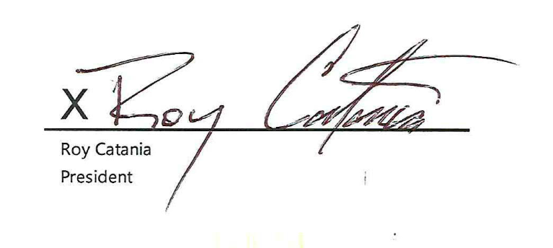
- Call in (audio only): Dial 1-559-512-2821
Conference ID: 347 518 970#

DATED: October 20, 2021

