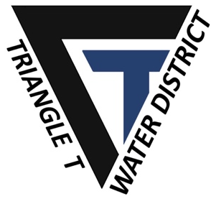

4400 Hays Drive
Chowchilla, CA 93610
TEL: (209) 665-1788

NOTICE OF CANCELLATION OF THE REGULARLY SCHEDULED MEETING OF THE BOARD OF DIRECTORS OF THE
TRIANGLE T WATER DISTRICT

Alternate formats of this agenda will be made available upon request by qualified individuals with disabilities. Appropriate interpretive services for this meeting will be provided if feasible upon advance request by qualified individuals with disabilities. Please contact the Interim Agency Secretary at (209) 883-8374 for assistance and allow sufficient time to process and respond to your request.

PLEASE TAKE NOTICE that the regularly scheduled meeting of the Board of Directors of the Triangle T Water District to be held on November 11, 2021 has been CANCELLED.

