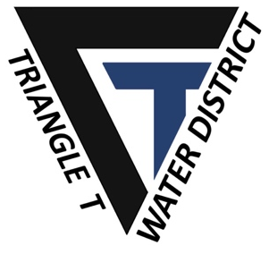

4400 Hays Drive
Chowchilla, CA 93610
TEL: (209) 665-1788

MEETING NOTICE AND AGENDA FOR A SPECIAL MEETING OF THE BOARD OF TRIANGLE T WATER DISTRICT

Alternate formats of this agenda will be made available upon request by qualified individuals with disabilities. Appropriate interpretive services for this meeting will be provided if feasible upon advance request by qualified individuals with disabilities. Please contact the Interim Agency Secretary at (209) 883-8374 for assistance and allow sufficient time to process and respond to your request.

PLEASE TAKE NOTICE that A Meeting of the Board of Directors of the Triangle T Water District will be held on Thursday, December 1st, 2025, at 1:00 PM at 541 H Street, Los Banos, CA 93635.

- ROLL CALL
- PUBLIC COMMENT - Interested persons in the audience are welcome to introduce any topic within the Agency’s jurisdiction. No action may be undertaken on any item not appearing on the posted agenda, except that the Board may briefly respond to the comments, refer the matter to staff, or request it be placed on a future agenda.

- SUBSIDENCE MITIGATION AGREEMENT
- 2026 BUDGET REVIEW
- CLOSED SESSION
  - REAL PROPERTY NEGOTIATONS
(Subdivision (d) of Gov. Code § 54956.8)
Property: Temporary Water Supply; Stevinson Water District
Agency Negotiator: Chase Hurley
Under negotiation: Price and terms of payment for water

- OTHER BUSINESS
- COMMENTS FROM THE BOARD
  - Board Members may provide a brief report on notable topics of interest. The Brown Act does not allow discussion or action by the Legislative Body.

- ADJOURNMENT

