Madera County Multibenefit Agricultural Land Repurposing Plan (MALRP)
A Regional Block Grant Deliverable for the Department of Conservation’s Multibenefit Land Repurposing Program (MLRP)
Approved by Board of Supervisors
October 1, 2024

Table of Contents
I. Terms and Definitions 4
A. MLRP State-Wide Program Key Terms 4
B. Madera County MLRP Key Terms 5
C. Acronyms 6
II. Executive Summary 8
A. MLRP Background 8
B. Madera County MALRP Overview 8
C. Funding Opportunity 8
III. Purpose 10
A. MLRP Program Goals 10
B. MLRP Requirements and Guidelines 11
IV. Background 12
A. Madera County Issues and GSP Objectives 12
B. Regional Block Grantee Team 15
C. Consulting team 15
D. Stakeholders 15
V. Madera Regional Goals, Objectives, and Strategies 17
A. Madera Goals and Key Outcomes 17
B. Madera Objectives and Strategies 17
C. Program Success Metrics 19
VI. Project Eligibility 20
A. Applicant Eligibility Criteria 20
B. Eligible Project Types and Definitions 21
C. Multibenefit Outcomes (Co-Benefits) and Definitions 22
D. Spatial Criteria 22
E. Other Requirements 26
VII. Project Solicitation and Selection Steps 28
A. Pre-Application and Eligibility Screening 28
B. Draft Proposal Development and Technical Assistance 28
C. Project Scoring and Selection 30
D. Contracting and Implementation 30
E. Program Revisions and Rounds of Funding 30
VIII. Project Scoring and Prioritization 31
A. Project Scoring Rubric 31
B. Criteria Assessment 40
IX. Incentive Payment Structure 42
A. Payment Categories 42
B. Payment Schedule 44
X. Project Management and Monitoring Plan 46
A. Termination 46
B. Monitoring Plan 46
C. Quantifying Program Benefits 47
D. DOC Grant Period Implications 48
XI. Consistency and Data 49
A. Consistency with Regional GSPs 49
B. Consistency with Best Available State, Regional, and Local Data 49
XII. Attachments 50
A. MLRP Project Implementation Review Packet (Template) 50
B. Pre-Application Form 50
C. Section VII: Project Solicitation and Selection Process Summary Table 50

Terms and Definitions

This document contains Madera County’s Multibenefit Agricultural Land Repurposing Plan (MALRP) key terms and definitions that have been defined by California Department of Conservation’s Multibenefit Land Repurposing Program (MLRP) programmatic guidelines as well as key terms and definitions that have been defined specifically for Madera County’s MLRP.

MLRP State-Wide Program Key Terms
Acre foot (AF): the amount of water required to cover an acre of land (an area that is about the size of a football field), one foot deep. Water yields are usually expressed in acre-feet per year (AFY).
Aquifer: an aquifer is the rocky structure underground that holds groundwater. Aquifers are filled when rain and melting snow sinks into the earth.
Community Health and Economic Well-being: Ensuring that land repurposing projects not only conserve water but also contribute to the health and economic prosperity of local communities.
Demand Management. Broadly encompasses any water management activity that reduces the use of water. To be effective for groundwater sustainability, demand management must result in a reduction in net groundwater pumping (pumping net of recharge), or alternatively, net depletion. This may include but is not limited to policies, programs, and technologies that when implemented result in a reduction in net depletion.
Disadvantaged Communities: Communities that experience greater environmental and economic hardships. The program aims to provide benefits to these communities through improved water management and sustainable land use practices.
Domestic/private well: a well on private property that serves no more than three households.
Evapotranspiration: part of water’s natural cycle. It happens when water vapor is released from the land and plants and goes back into the air.
Groundwater: Water beneath the surface of the earth within the zone below the water table in which the soil is completely saturated with water but does not include water that flows in known and definite channels.
Groundwater Basin or Subbasin: a specific area of land that sits over at least one aquifer where the groundwater is being used for many purposes, including but not limited to, drinking water, irrigation, and the environment, and conforms to Department of Water Resources designations for purposes of SGMA.
Groundwater Recharge: Practices designed to increase the amount of water that percolates into the groundwater system, thereby replenishing aquifers.
Groundwater Sustainability: Efforts to maintain a balance between water withdrawal and recharge in groundwater basins to ensure long-term water availability.
Nature-Based Solutions: Strategies that use natural processes and ecosystems to address environmental challenges, such as creating seasonal wetlands to enhance groundwater recharge and improve habitat connectivity.
Owner. The legal landowner of a parcel or the legal landowner’s designated agent.
Recharge: the replenishment or return of groundwater to the aquifer; it can happen naturally in the ground when it rains or artificially by spreading water for percolation or pumping water into the ground.
Regional Block Grants: Funding provided to regional or basin-scale organizations to develop and implement a Multibenefit Land Repurposing Program (MLRP). These grants aim to support coordinated, large-scale efforts to achieve groundwater sustainability.
Repurposing Agricultural Land: Transitioning irrigated farmland to alternative uses that require less water, such as wildlife habitats, renewable energy projects, or recreational areas.
Scalable and Transferable Models: Approaches to land repurposing that can be adapted and applied to different regions or contexts to maximize their impact and effectiveness.
Surface water: any body of water above ground, including streams, rivers, lakes, wetlands, reservoirs, and creeks.
Wildlife Habitat and Connectivity: Creating or restoring natural areas that provide shelter and resources for wildlife, and ensuring these areas are connected to allow for species movement and genetic exchange.

Madera County MLRP Key Terms
Eligible Project Type. A land repurposing project action that can be proposed and implemented by a MLRP Madera Participant. See Section VI for the list of Eligible Project Types.
Farm Unit. The defined areas of irrigated land (Parcel-Fields) managed as a single unit under the Madera County GSA Allocation Approach.
Field. A unit of farm land.
Madera County GSA. The exclusive Groundwater Sustainability Agency for the portions of the Madera Subbasin, Chowchilla Subbasin, and Delta-Mendota Subbasin that are not in other GSAs.
Madera County MALRP. The name for the Multibenefit Agricultural Land Repurposing Plan (MALRP) in Madera County that presents the strategy, framework, and plan for Madera County’s r Regional Block Grant MLRP.
Madera County Subbasins. The DWR Bulletin 118 defined groundwater subbasins that are in Madera County.
MLRP Agreement. The legal contract between an entity and the Madera County describing the terms and obligations of both parties. Also referred to as Agreement.
MLRP Madera. The Regional Block Grant name for the Multibenefit Land Repurposing Program (MLRP) in Madera County.
Net Water Savings. The reduction in consumptive use on irrigated or previously irrigated agricultural land from a baseline condition that represents consumptive use in the absence of the MLRP Madera project action.
Parcel. A unit of land associated with an Assessor Parcel Number.
Parcel-Field. A unique identifier that specifies the Assessor Parcel Number (Parcel) and field boundary, as defined in the Madera County GSA water tracking geospatial information.
Participant. An eligible landowner that enters into a MLRP Agreement with Madera County and DOC.
Repurposed Land. Lands that voluntarily enter into a MLRP Agreement with Madera County and Department of Conservation.
Undesirable Results. The Sustainable Groundwater Management Act (SGMA) defines undesirable results as one or more of the following effects listed below caused by groundwater conditions occurring throughout the basin. GSPs must address undesirable results and undertake management actions to ensure that they are avoided within 20 years of GSP adoption.
- Chronic lowering of groundwater levels indicating a significant and unreasonable depletion of supply if continued over the planning and implementation horizon. Overdraft during a period of drought is not sufficient to establish a chronic lowering of groundwater levels if extractions and groundwater recharge are managed as necessary to ensure that reductions in groundwater levels or storage during a period of drought are offset by increases in groundwater levels or storage during other periods.
- Significant and unreasonable reduction of groundwater storage.
- Significant and unreasonable seawater intrusion.
- Significant and unreasonable degraded water quality, including the migration of contaminant plumes that impair water supplies.
- Significant and unreasonable land subsidence that substantially interferes with surface land uses.
- Depletion of interconnected surface water that have significant and unreasonable adverse impacts on beneficial uses of the surface water.”

Acronyms
AF. Acre Foot
CA. California
COP. Community of Practice
DAC. Disadvantaged Communities
DOC. Department of Conservation
GSA. Groundwater Sustainability Agency
GSPs. Groundwater Sustainability Plans
MALRP. Multibenefit Agricultural Land Repurposing Plan
MLRP. Multibenefit Land Repurposing Program
PMAs. Projects and Management Actions
SGMA. Sustainable Groundwater Management Act
SMC. Sustainable Management Criteria
SHE. Self-Help Enterprises
SSE. Statewide Support Entity

Executive Summary

MLRP Background
The Multibenefit Land Repurposing Program (MLRP) is a California Department of Conservation (DOC) grant program funding local entities in regions needing to improve groundwater sustainability. As of 2024, Madera County is one of eight grantees across the state, receiving a $10 million Regional Block Grant to develop, manage, and implement a Multibenefit Agricultural Land Repurposing Plan (MALRP).
The MLRP program is designed to support California communities that are navigating changes driven by the Sustainable Groundwater Management Act (SGMA), which sets a deadline to transition to sustainable groundwater use by 2040 in this region. It is estimated that 400,000 to 1,000,000 acres of farmland in the San Joaquin Valley alone may need to be fallowed, retired, or repurposed to balance groundwater supplies and address climate change-driven water scarcity. If left unmanaged, fallowed or retired fields can emit dust and worsen air quality; host weeds and pests; and adversely impact agricultural economies, rural communities, and ecosystems. As a beneficial alternative, the MLRP aims to reduce these potential negative impacts and invest in solutions that provide benefits to both the environment and surrounding communities.

Madera County MALRP Overview
This Madera County MALRP document provides a comprehensive view of the programmatic goals and guidelines from DOC as well as the regional goals, objectives, and approach for administering the MLRP in Madera County. It offers both an understanding of DOC’s vision and framework for MLRP implementation and the specific approach for Madera County’s MLRP that was informed and developed by the MLRP Madera Partner Group. More information about the design and development of the Madera County MALRP, including a list of the entities that contributed to its content, is provided in Section IV of the document.

Funding Opportunity
In addition to representing the MLRP programmatic material, the Madera County MALRP also presents the proposed strategy, approach and plan for the MLRP Madera to award up to $7 million in implementation funds to support agricultural land transitions in Madera County.
The sections of the Madera County MALRP that present the solicitation design and plan for a MLRP Madera RFP are:
- Section VI: Eligible Project Types
- Section VII: Project Solicitation and Selection Steps
- Section VII: Project Scoring and Prioritization
The sections of the Madera County MALRP that present the approach for MLRP Madera incentive payments and monitoring plans for Participants are:
- Section IX: Incentive Payment Structure
- Section X: Project Management and Monitoring Plan
The Attachments section (Section XII) of this document contains DOC’s MLRP Project Implementation Review Packet template, which provides a checklist and descriptions of all elements required for a complete MLRP project proposal.

Purpose

The purpose of MLRP is to increase regional capacity for repurposing irrigated agricultural land to uses that reduce reliance on groundwater while providing community health, economic well-being, water supply, habitat, renewable energy, and climate benefits. DOC’ s vision for MLRP also includes a broader objective, which is for Regional Block Grantees to develop a scalable foundation for repurposing agricultural land that will initiate and support other models and efforts for land transitions into the future. This aim is in recognition that DOC’s grant alone ​​does not offer the funds and timeframe necessary to support the full scale and need for lands facing a change in the San Joaquin Valley.
This Madera County MALRP (Plan) document serves as a strategic framework designed to support voluntary transition of some agricultural lands into other productive uses that protect the agricultural industries in the county, provide private returns, support local jobs, and provide environmental and other social co-benefits. The MLRP Madera (Program) is voluntary. It provides technical assistance and financial incentives for participation and is intended to develop a scalable framework for encouraging landowners to develop creative approaches/projects for managing agricultural land and generating co-benefits as the county transitions to sustainable groundwater conditions by 2040. By leveraging innovative agricultural land management strategies, the MLRP not only seeks to address the challenges posed by SGMA implementation but also supports community resilience and economic development through sustainable agriculture, renewable energy, and recreational opportunities.
At the heart of MLRP Madera is a commitment to the county’s agricultural sector that supports jobs and income for local communities. The Madera County MALRP was developed with guidance and input from regional stakeholders, including landowners, local agencies, local community groups, and state agencies, as well as insights from other MLRP Regional Block Grantees and members of the MLRP state-wide Community of Practice (COP).

MLRP Program Goals
DOC presents the following goals for MLRP in the document MLRP Program Guidelines:
- Support Groundwater Sustainability: Foster coordinated, regional, and basin-scale efforts to achieve groundwater sustainability in critically overdrafted basins and high and medium priority basins where a state emergency drought declaration has been declared.
- Repurpose Agricultural Lands: Encourage the long-term repurposing of the least-viable agricultural lands to multibenefit opportunities, converting land to less intensive water uses while maintaining natural and working lands.
- Provide Drought Relief: Offer short- and medium-term drought relief measures to alleviate immediate water scarcity challenges.
- Sustain Land-Based Economies: Support regional efforts to sustain land-based economies impacted by groundwater sustainability measures, ensuring economic viability while reducing groundwater use.
- Enhance Wildlife Habitats: Create or restore wildlife habitats and connectivity, including seasonal wetland habitats to replenish aquifers and improve groundwater supply for fish and wildlife habitat.
- Promote Nature-Based Solutions: Implement nature-based solutions to reduce the impacts of hazards on lives, property, and the economy from overdrafted groundwater basins.
- Benefit Disadvantaged Communities: Deliver tangible benefits to disadvantaged communities and socially disadvantaged farmers and ranchers, ensuring equitable resource distribution.
- Foster Partnerships: Build partnerships and collaboration among diverse entities to enable regional-scale leadership in meeting program goals.
- Develop Transferable Models: Create scalable and transferable land repurposing models that can be adopted by other regions.
- Support Agricultural Leadership: Empower farmers, ranchers, and farm workers to lead in multibenefit land repurposing strategies and project implementation.
- Ensure Flexible Administration: Provide flexible and efficient program administration, allowing grantees to lead expeditious and adaptive programs that meet their specific needs.

MLRP Requirements and Guidelines
MLRP emphasizes the identification and prioritization of land repurposing strategies and projects that address groundwater sustainability within the region. DOC’s key requirements and guidelines include:
- Benefit Disadvantaged Communities: Projects must meaningfully benefit disadvantaged communities, improving their access to resources and quality of life.
- Least Viable Agricultural Lands: Focus on repurposing lands that are least viable for irrigated agriculture, thereby optimizing resource use and sustainability.
- Resource Connectivity: Contribute to resource connectivity, enhancing habitats, agricultural landscapes, and renewable energy projects.

Background

This section provides context for Madera County’s MALRP goals, outcomes, and program rules outlined in the document. It explores SGMA, GSP implementation, and water resource challenges in the county. It also describes the MALRP team and local partners and agencies that have developed this plan document.

Madera County Issues and GSP Objectives
Achieving and maintaining sustainable groundwater conditions in Madera County subbasins will include investments in supply augmentation projects and programs to reduce groundwater demand, including groundwater allocation programs. Groundwater management challenges are expected to increase under climate change, as agricultural lands have shifted to more permanent plantings, and as residential and industrial demand for water continues to increase. Key issues in Madera County are briefly summarized, followed by a description of how the MALRP supports GSP implementation in the subbasins, and explanation of the MALRP technical team and local project partners.

Key Issues
GSAs in Madera County are pursuing a range of projects and management actions to sustainably manage the subbasins by 2040. One key issue is that average annual groundwater overdraft for Madera County was estimated at approximately 260,000 acre-feet under 2015 cropping and historical hydrologic conditions. Projects to augment ground and surface water supplies are expected to be insufficient to address the overdraft. Substantial demand management is expected to achieve sustainable groundwater conditions.
Madera County includes portions of three groundwater Subbasins (Madera, Chowchilla, and Delta Mendota), with most of the groundwater use occurring within the Madera and Chowchilla Subbasins. There are 14 Groundwater Sustainability Agencies (GSAs) implementing Groundwater Sustainability Plans (GSPs) in Madera County. The Madera County Groundwater Sustainability Agency (GSA) covers “white area” lands without access to district surface water supplies in the Delta Mendota, Chowchilla, and Madera Subbasins and other GSAs include districts, cities, and areas with ground and surface water rights.
The Madera County Groundwater Sustainability Plans (GSPs) specified a series of projects and management actions that will be implemented to achieve sustainable groundwater conditions by 2040. For example, the Madera County GSA is developing projects to bring in additional groundwater recharge and new surface water supplies. The initial phases of groundwater recharge projects are currently under development with funding support from the Department of Water Resources Sustainable Groundwater Management Grant Program. The GSA has also implemented demand management actions including a groundwater allocation policy and multiple land repurposing programs.
Demand management programs include the amount by which groundwater pumping needs to be reduced to achieve sustainability by 2040, after accounting for new water developed under supply-augmentation projects. The net effect of planned demand management and supply augmentation in the Madera County GSAs included GSP demand management programs to decrease water use by approximately 90,000 acre-feet per year (AFY) in the Madera Subbasin, 28,000 AFY in the Chowchilla Subbasin, and 2,000 AFY in the Delta Mendota Subbasin. Additional demand management is planned in other GSAs in the Madera County Subbasins. These reductions will require significant changes to the current crop mix throughout the County.
The Madera County GSA has developed a land repurposing program, called Voluntary Land Repurposing, and implemented the DWR LandFlex land repurposing program in 2022/23. Even with these programs there is a substantial need to reduce groundwater pumping in the Madera, Chowchilla, and Delta Mendota Subbasins, within the Madera County GSA and other lands in the county. The County of Madera MLRP is intended to support these needs to achieve sustainable groundwater conditions.
Madera County produces a mix of nut crops, row crops, vineyards, and feed for the local dairy industry. This economic activity supports the local economy, providing jobs, income, and tax revenue for the benefit of Madera County residents. The Madera County economy produces over $6 billion per year in economic value added and supports around 63,000 full-time-equivalent (FTE) jobs. As of the 2010 U.S. Census, per-capita income was approximately $20,435 (in current dollars), or about 35% below the U.S. average of $31,895. Approximately 21% of the county population of 150,000 was at or below the poverty line, compared to the U.S. average of 12%. Over 75% of the county (by area) is classified as a Disadvantaged Community (DAC).
A substantial share of the Madera County economy is linked to farming or agriculture-related industries. Jobs and wage income for DACs in the county depend on farming and related industries in the area. Demand management programs that reduce water use by reducing farming activity must attempt to generate other co-benefits to limit the economic impacts to the county. The MLRP is intended to encourage creative solutions for agricultural land repurposing that protect the local economy and achieve subbasin sustainability objectives.

Consistency of Plan with GSP
The MLRP is developed for consistency with the Groundwater Sustainability Plans (GSPs) covering Madera County. All lands in Madera County are eligible to participate in the MLRP. Madera County is split between the following Subbasins that are covered by the following GSPs and GSAs:
Subbasin | GSPs (Groundwater Sustainability Plans) | GSAs (Groundwater Sustainability Agencies)
Delta Mendota Subbasin | Delta Mendota GSP | Madera County GSA – Delta Mendota Subbasin
 |  | Aliso Water District GSA
 |  | San Joaquin River Exchange Contractors Water Authority GSA
Madera Subbasin | Madera Joint GSP | City of Madera GSA
Madera Subbasin | Madera Joint GSP | Madera County GSA – Madera Subbasin
Madera Subbasin | Madera Joint GSP | Madera Irrigation District GSA
Madera Subbasin | Madera Joint GSP | Madera Water District GSA
Madera Subbasin | Gravelly Ford Water District GSP | Gravelly Ford Water District GSA
Madera Subbasin | New Stone Water District GSP | New Stone Water District GSA
Madera Subbasin | Root Creek Water District GSP | Root Creek Water District GSA
Chowchilla Subbasin | Chowchilla Subbasin GSP | Chowchilla Water District GSA
Chowchilla Subbasin | Chowchilla Subbasin GSP | Madera County GSA – Chowchilla Subbasin
Chowchilla Subbasin | Chowchilla Subbasin GSP | County of Merced GSA – Chowchilla Subbasin
Chowchilla Subbasin | Chowchilla Subbasin GSP | Triangle T Water District GSA

Madera County GSPs have outlined groundwater conditions, water balance, Sustainable Management Criteria (SMC), and steps to achieve sustainability by 2040. This includes various Projects and Management Actions (PMAs) to prevent GSAs from realizing any Undesirable Results attributable to groundwater use. This section documents ways in which the projects intended to be funded under the MLRP support GSP implementation activities.
PMAs developed by GSAs in Madera County broadly include projects to increase surface water deliveries, projects to increase groundwater recharge, developing incentives for groundwater users to pump less groundwater, and, for the Madera County GSA, implanting a groundwater allocation policy limiting consumptive use of groundwater.
The Madera County MALRP is consistent with the Madera County GSPs.
- Multiple GSPs in Madera County include demand management programs to reduce groundwater pumping in the county. Demand management programs are generally defined in the GSPs as a phased, planned reduction in pumping. The Madera County GSA has implemented a groundwater allocation to achieve this objective and other GSAs are considering demand management programs. The MLRP will help landowners reduce demand by repurposing lands to a lower water use activity.
- Existing and new groundwater recharge basins rely on excess flows during wet and normal water years. Operation of recharge facilities is most cost effective when excess flows are more consistently available. Some MLRP projects may reduce agricultural use of surface supplies, which would make more water available for recharge. Other MLRP projects may support direct recharge opportunities.
- Multiple GSAs are pursuing purchases and exchanges for additional water supplies from other districts. Reduced demand for water within Madera County from MLRP repurposing projects may be a more cost-effective source of new water compared to purchases and exchanges.
- Some GSAs are exploring incentives to encourage surface water use in lieu of groundwater pumping. MLRP projects for parcels on dual systems may reduce groundwater pumping because of project implementation.
The MLRP is consistent with Madera County and GSA goals to comply with SGMA. The MLRP helps address SGMA sustainability indicators including chronic lowering of groundwater levels, reduction in groundwater storage, land subsidence, and surface water depletion by helping all GSAs in the county achieve voluntary reductions in groundwater use.

Regional Block Grantee Team
Madera County is responsible for overseeing, managing, and administrating the MLRP Madera Block Grant. There are several other entities that make up the MLRP Madera Partner Group, which includes sub-contracted entities and collaborating entities to support the design, development and implementation of Madera County’s MALRP. The entities that are part of the MLRP Madera Partner Group include:
- Madera County
- Madera/Chowchilla Resource Conservation District
- Madera County Farm Bureau
- Madera Ag Water Association (MAWA)
- California Farmland Trust
- Linguistica

Consulting team
Madera County has contracted with Zanjero, a water resources management consulting firm, to help lead the design, development and implementation of the MLRP Madera program. Zanjero oversees two sub-consultants who also contribute to this effort, which include ERA Economics and Davids Engineering.

Stakeholders
The MLRP aims to engage a diverse and comprehensive community of stakeholders to provide input on the design and implementation of all regional MALRPs. For Madera County’s MALRP, the following entities have been engaged as part of the input and planning process.
- Leadership Council for Justice and Accountability
- Self Help Enterprises (SHE)
- Fairmead Community and Friends
- River Partners
- Union of Concerned Scientists
- Madera Coalition for Community Justice (MCCJ)
- Sustainable Conservation
- University of California Cooperative Extension (UCCE) Madera County
- Punjabi American Growers Group (PAGG)

Madera Regional Goals, Objectives, and Strategies
The regional goals, objectives and strategies for Madera County’s MLRP are outlined below. This presents the strategic framework for how all aspects of Madera County’s MALRP was informed by extensive outreach among key stakeholders representing landowner, community, environmental interests. This framework also reflects the goals and intent of DOC’s MLRP guidelines, and offers pathways for the MLRP Madera to leverage DOC grant funds to gain and sustain funding for land repurposing projects beyond the limited scope of MLRP.

Madera Goals and Key Outcomes
- Support the transition of agricultural landscapes to sustainable groundwater conditions: Support near- and long-term changes to the agricultural landscape in Madera County, promoting sustainable and diverse land uses.
- Achieve water savings from land repurposing projects: Ensure water savings are achieved and maintained, contributing to overall water resource management.
- Deliver meaningful co-benefits. Encourage land repurposing projects provide meaningful co-benefits to Disadvantaged Communities (DAC), the environment, and local economy.

Madera Objectives and Strategies
The Madera MALRP regional objectives and supporting strategies presented below have been developed out of a collaborative and inclusive planning process involving Madera MLRP block grantee partners and key regional stakeholders. The Scoring Rubric section of the Madera MALRP further describes and represents how the goals and objectives guide the project prioritization and selection process for Madera’s MLRP.

Objective 1: Increase grower interest and participation in MLRP and land repurposing strategies and programs.
Strategy and Approach:
- Conduct education and outreach activities to inform growers about the benefits and opportunities of the MLRP.
- Communicate use cases and success stories to illustrate tangible examples and learning opportunities.
- Provide resources and technical assistance to grower participants.

Objective 2: Strive to develop and implement a portfolio of at least six (6) land repurposing projects that are beneficial, specific, measurable, achievable, resourced, and timebound (B-SMART).
Strategies and Approaches:
- Incentivize and prioritize projects within multibenefit priority zones as follows:
  - Within 1 mile of a community or dry domestic well, with additional preference for such wells that serve a DAC.
  - Within 1 mile radius of a DAC.
  - Directly adjacent to a waterway.
- Select project proposals that create positive impact for local communities be consistent with Groundwater Sustainability Plans (GSPs).
- Develop a robust project management and monitoring plans to track, measure, and verify water savings and benefits achieved.
- Ensure projects are feasible within the MLRP grant funding period and secure resources for implementation and maintenance over a 10-year period.
- Adhere to timebound aspects of MLRP and other funding sources in project proposals and landowner contracts.

Objective 3: Strive to achieve 10,000 AF of net water savings from MLRP Madera’s portfolio of projects over a 10-year period.
Strategies to Meet Objective:
- Prioritize projects that target 500 AF or more of estimated net water savings as part of MLRP scoring and selection process over a 10-year period.
- Incentivize water savings through a structured project incentive payment system.
- Use the scoring and selection process to prioritize projects that are more cost effective per acre foot of net pumping reduced.

Objective 4: Establish a programmatic solution for MLRP Madera that is sustainable and scalable over a minimum of 10 years.
Strategies to Meet Objective:
- Work with an appropriate entity (i.e. Central Valley Community Foundation who already has an adjacent program to MLRP) to develop a proposal for DOC to grant funds to a land repurposing program for Madera County, requesting up to $1 million in implementation funds. This program would provide a durable solution for securing DOC funds for the purposes of building local capacity to sustain and maintain land repurposing projects that need it, solving for the barriers created by DOC’s grant timeframe.
- Create and implement a comprehensive plan to solicit and secure additional land repurposing funds from public and private entities to be managed and mobilized by an on-going land repurposing program. This strategy would strive to leverage DOC’s dollars as seed funding that would attract opportunities for more funding to be secured for land repurposing projects in Madera County.

Program Success Metrics
Program success metrics are measurable outcomes from the Madera County MLRP that will be tracked and used to assess whether the program is meeting its objectives.
- The Madera County MLRP is developing resources and outreach materials to increase grower interest and participation in the program. Success will be measured by:
  - Number of attendees at outreach activities.
  - Number of calls received expressing interest in the program.
  - Total number of project proposals received.
- The Madera County MLRP aims to implement multiple small-scale projects that achieve a diverse portfolio of multi benefit outcomes. Success will be measured by:
  - The total number of projects successfully implemented.
  - The number of multi benefit outcomes achieved by the different projects.
- The Madera County MLRP aims to protect and improve access to groundwater for municipal and domestic uses, with an emphasis on municipal and domestic uses in DACs. Success will be measured by:
  - Total number of community wells affected by project implementation.
  - Total number of dry domestic wells affected by project implementation.
  - Total number of community wells affected by project implementation that serve DACs.
  - Total number of dry domestic wells affected by project implementation that serve DACs.
- The Madera County MLRP aims to support groundwater sustainability in the County by reducing groundwater extraction. Success will be measured by:
  - Total reduction in groundwater pumping resulting from project implementation.
  - Project funding spent per acre foot of groundwater reduction achieved.
- The Madera County MLRP aims to ensure successful implementation of selected projects through project monitoring and reporting. Success will be measured by:
  - Number of projects that adhere to their implementation plans, including implementation timelines.
  - Number of projects that adhere to planned monitoring, maintenance, and reporting.
- The Madera County MLRP aims to establish a programmatic solution for the County that is sustainable and scalable over a minimum of 10 years. Success will be measured by:
  - Amount of additional funding secured to adequately support annual program implementation costs over a 10-year period.
  - Interest and engagement from additional partners to further land repurposing strategies and programs beyond the DOC grant period.

Project Eligibility

Projects developed through the MLRP program aim to reduce groundwater use, improve water quality, restore habitat, improve access to nature, and increase regional workforces or diversify economic opportunities, particularly in disadvantaged communities and farmworker communities. Eligibility requirements for applicants to apply for MLRP funding in Madera County are outlined the following sections.

Applicant Eligibility Criteria
All Applicants for MLRP Madera funding must meet the minimum eligibility requirements. Screening for these requirements is the purpose of the pre-application process that is described in more detail in Section VII of this document. All Applicants must submit a pre-application within the pre-application window and pass eligibility screening in order to submit a project proposal.
A list and description of each of the eligibility requirements for MLRP Madera Applicants is provided below.
- The Applicant must be the Owner (or the Owner’s designee) of the lands being offered for the program and willing to comply with all contract terms and program provisions. This includes requiring that lands be within a GSA and within Madera County. See sections below. Madera County retains sole responsibility for determination of eligibility and may modify eligibility terms at any time based on evolving conditions.
- The Applicant must be willing to repurpose currently irrigated agricultural lands for another project use as defined in the section below for the duration of the project period (a minimum of 10 years). Madera County reserves the right to add a provision to allow Applicants with previously irrigated agricultural lands to be eligible for the program if the proposed project offers unique co-benefits that meet the expressed needs or interests of a DAC. The agricultural lands and project type being proposed for a project must be in alignment with DOC’s MLRP guidelines.
- The Applicant must comply with all program rules defined in this document and by the GSA in which the Parcel is located. This includes paying all taxes and fees, including any GSA or GSP assessments or fees.
- The Applicant must propose a project that would implement at least one eligible project type to convert irrigated agricultural lands to a less water intensive use. (See section below for more details regarding eligible project types.)
- The project must provide one or more co-benefits, which are benefits in addition to any water savings provided by the project. Project co-benefits were broadly defined by the Department of Conservation for the MLRP and were refined with local stakeholder input. Projects that provide multiple benefits, or contribute a greater amount of a specific benefit, are more desirable and thus may rank higher than alternative projects that provide fewer benefits. However, minimum eligibility requires a project to provide at least one of the defined co-benefits as defined in the section below.

Eligible Project Types and Definitions
Project Type | Description
Community recreational area or cultural space | Convert land into a community area with opportunities for recreation, publicly accessible open space, or specific cultural uses. Conversion may include a change in ownership or a land lease involving one or more parties.
Dryland farming | Convert to growing a crop that solely relies on precipitation falling onto the field to grow an agricultural commodity, with no supplemental irrigation. Differs from less water-intensive because there is typically no irrigation system, and no applied irrigation water. Can serve as a transition crop and be flexible year to year.
Floodplain habitat | Modify land along natural waterway or flood channel to facilitate spreading of water during high-flow events. Land would be replanted with appropriate native plants to create valuable habitat during periods without any water inundation. Land modifications can also facilitate groundwater recharge.
Less water-intensive crop | Convert to growing a crop that uses less water than the current irrigated crop, including a crop that still requires regular irrigation, or a crop that needs only minimal irrigation to supplement precipitation. Differs from dryland farming due to the presence of an irrigation system. Must consider market demand and specialized labor need.
Rangeland (Managed Grazing Land) | Convert irrigated lands to non-irrigated land for livestock grazing. Land would be replanted and managed to facilitate healthy grazing plant species and practices. May include land preparation, replanting, weed management, fencing, livestock watering systems, and other facility improvements to provide necessary functionality.
Pollinator habitat | Convert land to support important native pollinator species through planting, propagation, and management of appropriate native plant species. Can be planted field-wide or as hedgerows.
Recharge basin or facilities | Modify land to create a dedicated basin or facilities where acquired surface water can be placed for seepage into underground storage. Recharge credits may be available, depending on the rules of the Groundwater Sustainability Agency within which the recharge basin or facility is located.
Rotational strip cropping | Modify the farming and management practice of annual crops such that different strips of the field are planted each year, resting the soil on non-planted strips.
Solar energy production, storage, transmission | Convert land to accommodate solar energy production, or to provide an area for needed energy storage facilities and transmission corridors. This could also include Agrivoltaic projects that combine solar generation with commodity farming.
Wildlife habitat | Convert land to support important native plant and animal species through planting, propagation and management of appropriate plants. Irrigation may be necessary to establish plants, but habitat would not rely on irrigation after establishment. Should consider the distance to existing habitat to connect large areas and create more successful habitat. Working with wildlife agencies will ensure projects are properly permitted and that project implementers have guaranteed assurances.

Multibenefit Outcomes (Co-Benefits) and Definitions
Co-Benefit | Description
Air quality improvement | Reduces dust, chemicals or other sources of particulate matter that impact the air quality within and around the project location.
Employment opportunities | Creates new jobs or supports job security.
Tribal or cultural benefit | Provides space dedicated to traditional land uses, cultural traditions, or the arts.
Soil quality enhancement | Includes land maintenance and management practices to promote soil health or prevent erosion.
Water quality enhancement | Supports improved water quality of community or domestic wells.
Renewable energy | Creates a clean energy source that helps California reduce its climate impacts.
Habitat creation | Improves regional biodiversity supports the recovery of plants and animals that are at risk of extinction.
Recreation or community space | Offers opportunities for recreational, educational or other space to enhance community well-being.
Flood risk mitigation | Provides a diversion point or dedicated area for flood flows to reduce downstream flood risks to communities and farmland.

Spatial Criteria
Eligible projects must be located in a GSA in Madera County and meet the characteristics as defined in the previous section. The proposed land use must also be consistent with existing zoning. There are no additional spatial criteria that define whether a project is eligible for the program. However, funding for the Madera County MLRP is limited by the DOC grant. Projects are evaluated and scored based on a competitive process. The scoring, ranking, and prioritization process, which is defined in Section VII of this document, represents how certain spatial characteristics are prioritized in Madera County’s MALRP. This section summarizes spatial criteria that reflect local stakeholder input on the MLRP and are included in the scoring approach.

Proximity to At-Risk Community and Domestic Wells
A key goal and outcome of the MLRP is to support the reliability of community and domestic wells. Parcels that are located closer to at-risk community and domestic wells are prioritized above parcels that are farther way. At-risk community and domestic wells were evaluated in the State Water Resources Control Board (SWRCB) Safe and Affordable Funding for Equity and Resilience (SAFER) program database and the domestic well database from the Department of Water Resources. “At-risk” wells considered in the MLRP include community wells and domestic wells that are at risk of failure (i.e., dewatering or ‘going dry’). Community wells that serve a greater population, are at risk, or have recently been designated as failing are given higher priority. All parcels within 1 mile of the domestic or community well are in locations that are desirable for the MLRP goals of supporting community and domestic wells. Figure 1 illustrates the general location of priority community and domestic wells and associated parcels within 1 mile. See Section VIII for how the proximity to at-risk community and domestic wells is used in project scoring.

Figure 1. Madera County At-Risk Community and Domestic Wells (DWR and SWRCB SAFER Databases)
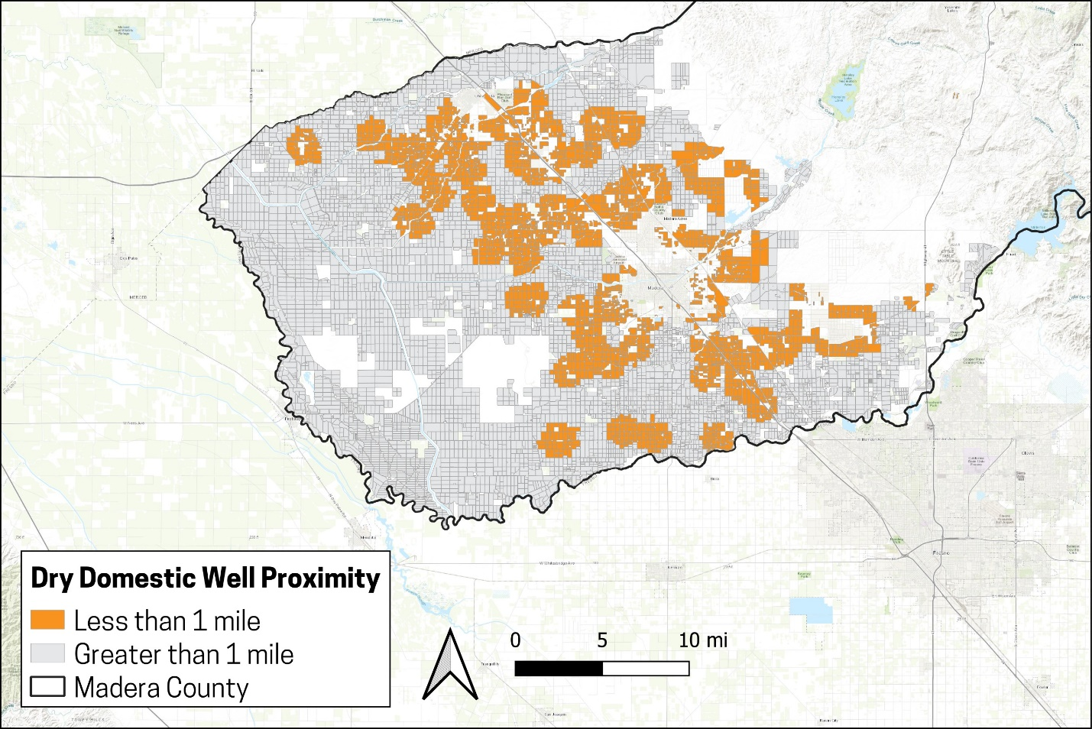

Proximity to Disadvantaged Communities
Another key goal and outcome of the MLRP is to support disadvantaged communities. Most of Madera County is classified as an economically disadvantaged community (DAC) based on the state definition of a DAC. To provide more precise spatial preferences for the program, the MALRP defines a spatial preference for parcels closest to existing communities in Madera County. A higher weight is assigned for parcels that border communities. Figure 2 illustrates communities in Madera County and parcels near those communities. See section VIII below for how the proximity to existing communities is used in scoring.

Figure 2. Madera County Communities
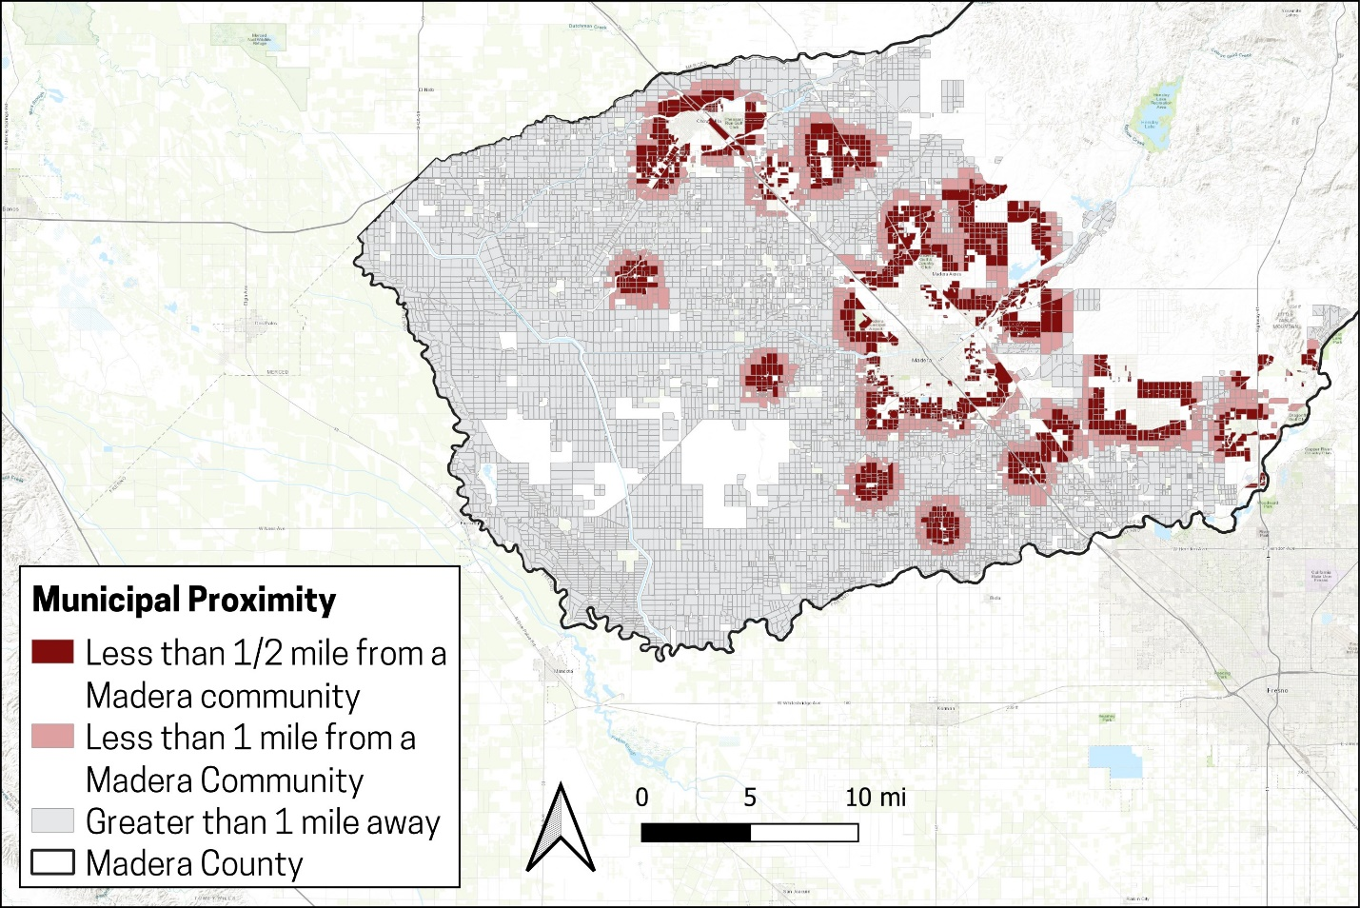

Proximity to Waterways
The third program goal and outcome is to provide buffers around waterways in the county for the purposes of mitigating flood risk and creating floodplain habitat. County waterways were reviewed and classified as high priority streams and other (low) priority waterways (which may include seasonal steams and similar small channels). The high priority waterways include the Chowchilla River and Ash Slough, Berenda Slough, Fresno River, Eastside Bypass, and the San Joaquin River. High priority waterways are designated as such because these provide additional flood risk benefits for communities in Madera County. Figure 3 illustrates example waterways and parcels near those areas. See Section VIII for how the proximity to waterways is used in scoring.

Figure 3. Madera County Waterways
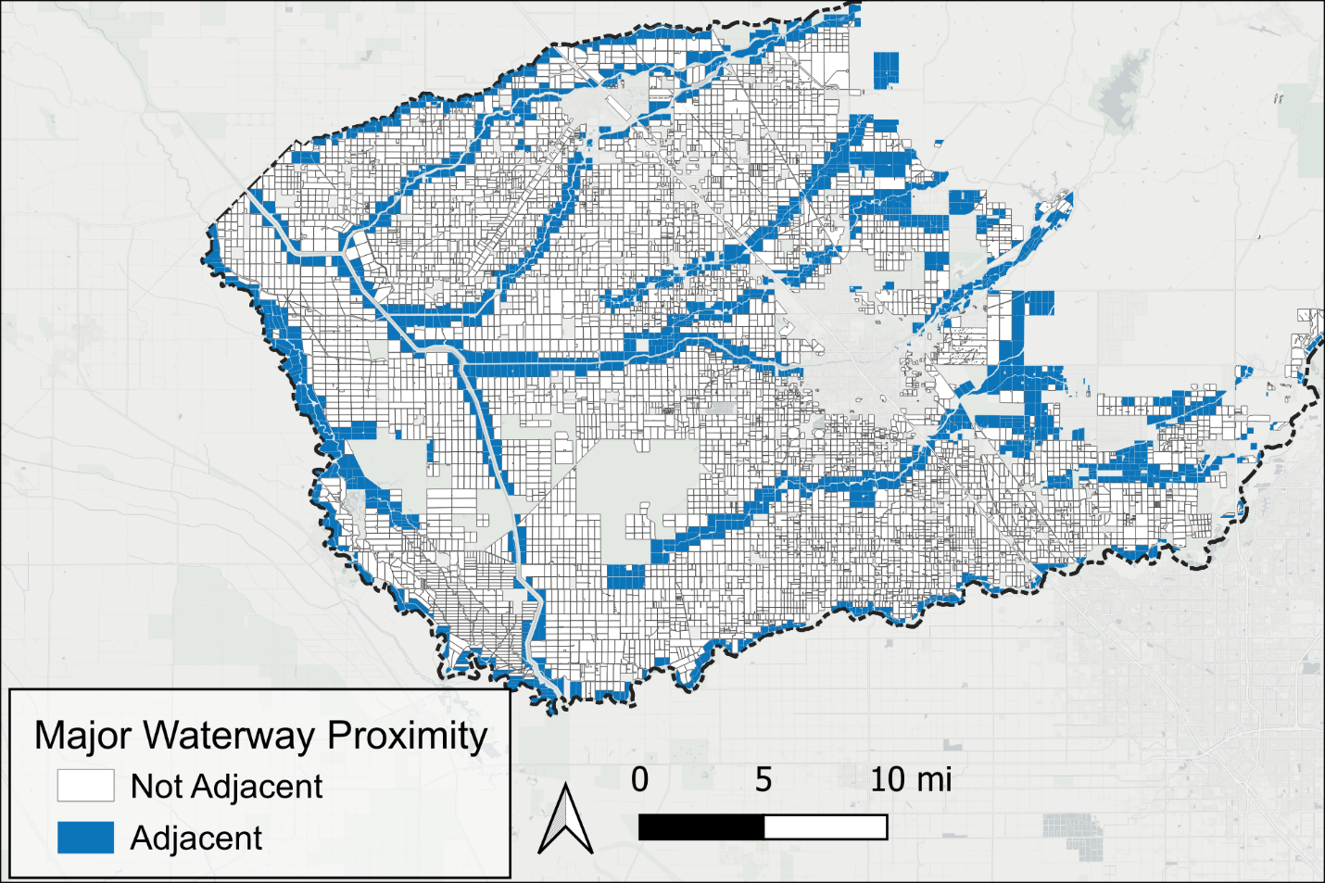

Other Requirements
An Applicant that has a project selected for the MLRP Madera will be required to comply with the rules of the Madera County MALRP, including rules specified by DOC in its MLRP grant program materials. The process for proposal development and selection are described in Section VII. Additional requirements may include but are not limited to those summarized below in this section.
Each Applicant must prepare and submit a project proposal, using DOC’s MLRP Project Implementation Review Packet template checklist and guidelines to ensure their proposal package addresses all the required information and documentation. This template is included as an attachment in Section XII of this document to reference for the detailed checklist. The MLRP Madera Technical Assistance Team may assist Applicants with preparing the MLRP Project Implementation Review Packet.
If the project is selected for inclusion in the MLRP Madera portfolio of recommended projects at the conclusion of the project scoring and selection process (described in Section VII), the MLRP Project Implementation Review Packet along with supporting documentation would then be submitted to DOC for review and approval.
The Applicant will be required to prepare and submit basic project information. This includes but is not limited to a project justification and summary of the name, location, size and purpose of the project. It also includes the APN(s) and intended co-benefits. The project Applicant must also disclose agricultural viability of the project lands and state whether the project contributes to resource connectivity goals. Applicants will be made aware what level of project details and information will be included in the submission to DOC, including what information would be considered public information, prior to packet delivery.
The project must demonstrate that it meets the goals of the MLRP Madera program (see Section IV) in addition to DOC program goals. It must demonstrate the intended project benefits and outcomes. This includes preparing a draft monitoring plan and management plan that describes how the Applicant will monitor and manage the project for the duration of the project (a minimum of 10 years). Intended project outcomes will include a summary of any net water savings in addition to other co-benefits that will be achieved.
The Applicant may be required to enter into other agreements with third-parties to implement the project where such third-parties are providing additional services or funding. For example, if the Resource Conservation District assists with a habitat project it may require the Applicant to enter into an agreement to access the property and develop habitat. Any such agreements would be defined as part of the project selection and implementation process.
An assessment of any groundwater recharge (or water savings) benefits must be completed for projects that would provide recharge benefits. This includes a summary of water savings. The Applicant is required to coordinate with the GSA to have the GSA, or its designated technical staff, certify the recharge and water savings amounts.
The Applicant will be responsible for ensuring all project permitting is addressed in the project application process. Permitting would likely require California Environmental Quality Act (CEQA) compliance, which will be determined and coordinated with the County on a project-specific basis. Many projects are expected to be CEQA exempt, however exemption determinations cannot be made until a proposed project is understood by the County. Large, complex, or controversial projects may require more extensive CEQA or other permitting, which may create risks to be accomplished within the MLRP grant application and award timeframe.
The project must be managed to prevent and mitigate nuisances in accordance with applicable local, state, and federal laws and regulations.
The Applicant/Owner and project parcels must be in compliance with all GSA policies or regulations. This may include but is not limited to GSA fees, allocations, and other reporting requirements. In addition, the Applicant/Owner must not be delinquent on local, state property taxes, assessments, and fees. The GSA will determine in its sole discretion if the Applicant/Owner is in compliance with GSA policies or regulations. The GSA process for determining non-compliance will follow the policies and procedures of the individual GSA, as appropriate.

Project Solicitation and Selection Steps
This section outlines the complete process that all interested parties must adhere to in order to apply for and receive MLRP funding in Madera County, which includes:
- Pre-Application and Eligibility Screening
- Project Proposal Development and Technical Assistance
- Project Scoring and Selection
- Contracting and Implementation

Pre-Application and Eligibility Screening
Participation in the MLRP Madera program starts with an interested Applicant submitting a pre-application to determine if they meet the minimum requirements and are eligible to apply. As part of this initial application, the Applicant then selects an eligible project type and indicates which lands would be included in the implementation of the proposed project action.
It is important to note that all parties who are interested in participating in the MLRP Madera program and funding opportunity must submit a pre-proposal application within the pre-proposal application period. The pre-proposal application and eligibility period for MLRP Madera program applicants will be seven weeks spanning the timeframe of October 4 to November 22, 2024.
As described in Section VI, the purpose of the pre-application is to ensure that interested parties meet the minimum eligibility requirements before beginning the proposal development process. The eligibility screening process will also require that Applicant/Owner (or the Applicant/Owner’s designee) of the lands being offered for the program are willing to comply with all contract terms and program provisions (see sections below).
The Madera MLRP will post the pre-application form (in English and Spanish) to the MLRP page on the maderacountywater.com website for interested parties to view and download. The pre-application form is also provided as an Attachment to this plan. Language assistance for interpreting the application to any language other than English and Spanish will be offered to any interested parties who may need it.
To submit the pre- application form, applicants will be provided with both an email address and physical mailing address to send completed applications within the pre-application period. In-person appointments or other direct assistance services may be offered to applicants who need assistance filling out the form.

Draft Proposal Development and Technical Assistance
Participants in the MLRP Madera project development process will be provided both informational and technical assistance (TA) resources to help them prepare their proposals. The process, which is expected to begin in mid-November 2024, will begin with on-boarding support where Applicants will be given detailed guidance on how to prepare their proposals. An MLRP Technical Assistance Team (TA Team) will be developed at the direction of the County in consultation with MLRP partners. The TA Team will hold workshops that will include a presentation on proposal requirements, tips for writing a good proposal, schedule, proposal scoring and selection, and other details about the overall process. A question-and-answer session will follow. Following the presentation and general questions, members of the Technical Team will be available to answer more specific or detailed questions.
The workshops will also provide information on the services and resources available to Applicants to develop their draft proposals, which may include in-person and virtual options for one-on-one technical assistance with appropriate parties from the MLRP Madera TA Team as well as other supporting stakeholder entities. During a TA session, the TA Team will, as requested, answer questions on, for example how to formulate and refine a project proposal, the appropriate amount of detail and explanation to include, and needed or helpful supporting information such as schedules, budgets, and maps. If possible, the Applicant should indicate questions or topics ahead of the help session so that appropriate team members can respond.
In order to maintain fair access to assistance by all applicants, the TA Team will follow the following protocols in its individual help sessions:
- Each session will last a maximum of one hour per Applicant, per project.
- The TA Team will answer questions and discuss information brought to the session by the applicant. The Applicant may submit specific questions or topics to the TA Team prior to the session, but the TA Team will not review portions of an application draft ahead of the session.
- The TA Team will not prepare any part of an application for an applicant, nor will it provide any judgment on the probable success of an application.
- The TA Team will treat all applicants equally and provide accurate information. However, the TA Team cannot warrant that information it provides to an Applicant will guarantee the completeness or success of the application.
- The TA Team will treat any proposal-specific information provided by an Applicant during a session as confidential.
- The TA Team may take notes during each session to document the discussion. The TA Team may follow up with the Applicant if it needs to clarify or adjust its response to a question.
- If questions or issues are identified during one or more sessions that are of general interest to all applicants, the TA Team may publish them in an FAQ. No project-specific information will be revealed in the FAQ.
Draft proposals will be expected to contain the project’s objectives, description, maps and photos of the agricultural land to be repurposed, quantification of any anticipated net water savings, identification of the co-benefits to be achieved, budget, implementation timeline, and a management and monitoring plan. Project applicants will also need to address DOC requirements for any relevant outreach and engagement with community or other stakeholders about their proposed projects. The TA Team will be available to help applicants understand and navigate these outreach requirements in a way that makes sense for their specific project plan.
The anticipated time period for applicants to develop draft and final versions of their proposals is November 2024 to February 2025. The Madera MLRP will have a web interface and email for Applicants to submit proposal materials.

Project Scoring and Selection
Complete proposals submitted by the deadline will be reviewed, ranked and assigned a numerical score. The process for scoring is defined in Section VIII of this MALRP.
A criteria assessment and project scoring team will review and score the projects as defined in Section VIII. Members of the criteria assessment and project scoring team must have technical expertise and a thorough understanding of the Program and Plan to properly evaluate proposals. Members of the criteria assessment and project scoring team must not have any conflicts of interest that would prevent an unbiased and fair assessment of projects being scored. The same scoring participants will be used across projects.
After projects are scored, the top scoring projects will then be assessed in the context of the total amount of funding available for MLRP Madera project implementation funds. This assessment will take into consideration the proposed budget for each project and their respective co-benefits that would be created. The goal of this assessment is to create a project portfolio recommendation for funding that best aligns with MLRP Madera’s regional goals and objectives. The project portfolio recommendation will be posted on the MLRP Madera web page for public comment. See Section VIII for more details regarding the project scoring, prioritization, and selection process.

Contracting and Implementation
Projects that pass the review and approval process with DOC will advance for the Applicant to enter into a contractual agreement with Madera County for MLRP funding awards. The agreement will define (restate) the terms of the contract and project and be approved by the Madera County Board of Supervisors.

Program Revisions and Rounds of Funding
The Madera County MALRP is committed to meeting evolving GSP and economic needs in the county subbasins. To ensure the program remains effective and relevant, a structured process for updating the program is in place. This process involves regular reviews of program outcomes, stakeholder feedback, and changes in GSP implementation. Based on these assessments, components of the MALRP may be revised to better align with stakeholder needs. These updates are essential for aligning the program with the latest data and community needs, ensuring that it continues to achieve its intended benefits.
Whether or not the program is updated, additional rounds of applications may be opened to attract new projects or allow previous applicants to reapply under revised guidelines. Any subsequent rounds will follow the same pre-application, application, scoring, review, and selection process as the initial round. However, each round may be informed by the lessons learned and feedback from earlier phases. By potentially offering multiple rounds of applications, the MALRP can maintain flexibility, encourage broader participation, and support a diverse range of projects that contribute to its overarching goals.

Project Scoring and Prioritization
The MLRP funding is initially limited to the amount of the DOC grant. The MLRP Madera Regional Block Grant Team will continue to work with DOC, other agencies, and applicants to identify additional funding sources. Since funding is limited, the MALRP includes a process for scoring and ranking full project proposals to maximize the current DOC funding to achieve MLRP program goals and outcomes (see Section V). The scoring criteria and prioritization approach is described in this section of the MALRP.

Project Scoring Rubric
Project scoring was developed with MLRP stakeholder input to reflect the goals and outcomes of the MALRP. Scoring is split into two categories: key goals and outcomes, and proposal quality and project feasibility.
Project scoring for key goals and outcomes reflects how well the project aligns with stakeholder objectives for multi-benefit land repurposing in the Madera GSAs. Key goals and outcomes were defined and described in Section V, and include:
- Support transition of irrigated agricultural landscapes to alternatives, including continued farming, as defined in this plan document
- Achieve water savings
- Deliver meaningful co-benefits
Project scoring for proposal quality and feasibility considers how well the project is developed, funded, consistent with the GSP, and the overall timeline and feasibility for implementation. Proposal quality and feasibility considers the following:
- GSP consistency
- Robust management and monitoring
- Feasible within the funding period
Five project metrics were developed for key goals and outcomes and four items were developed for proposal feasibility and quality, for a total of nine (9) categories for scoring. Each category is weighted equally with a maximum score of 4 points (8 for budget). The total maximum score is 38 points (18 for key goals and outcomes and 20 for proposal quality and feasibility). Table 1 summarizes the proposal scoring rubric.

Table 1. MALRP Project Scoring Approach Overview
Key Goals and Outcomes | Points | Proposal Quality and Feasibility | Points
Provide Other Co-Benefits | 4 | Overall Plan | 4
Achieve Net Water Savings | 2 | Budget | 8
Support Community and Domestic Wells | 4 | Schedule | 4
Buffer Waterway Areas | 4 | Monitoring Plan | 4
Support DSC | 4
Total | 18 |  | 20

Key Goals and Outcomes: Provide Other Co-Benefits
Projects that provide multiple co-benefits are prioritized. A project that provides one co-benefit will receive 2 points. Projects that provide two or more co-benefits will receive 4 points. There are 9 eligible co-benefit outcomes:
- Air Quality: Projects can demonstrate air quality benefits if the project addresses one or more of the EPA’s five established major air pollutants. These include 1) ground level ozone, 2) particle pollution, 3) carbon monoxide, 4) sulfur dioxide, 5) nitrogen dioxide.
- Employment: Projects that maintain regional employment by keeping land in productive uses.
- Flood Risk: Habitat, recharge, and recreation sites each have the potential to mitigate flood risk. Wetland habitat and recharge facilities will automatically be categorized as providing flood risk benefits.
- Habitat: Projects that increase habitat in the county may qualify for habitat co-benefit creation if they demonstrate viable species habitat as part of their project.
- Recreation or cultural space: Recreation facilities and other project types that provide a qualified recreation amenity will qualify for recreation co-benefit creation.
- Renewable Energy: Solar generation, transmission, and storage projects will qualify for renewable energy co-benefit creation.
- Tribal Benefit: Projects that convert land for tribal use will qualify for tribal co-benefit creation.
- Soil Quality: improvements to soil quality on farmed lands.
Project proposals will define how their project provides an improvement in one of the co benefit categories that can be measured and demonstrated.

Key Goals and Outcomes: Achieve Net Water Savings
Projects that reduce groundwater pumping in the County support the programs’ broader goal of achieving groundwater sustainability. For a project to qualify as reducing groundwater pumping, the proposal must demonstrate a net reduction in groundwater extraction relative to the established baseline water use at the project location. Points will be allocated relative to the parcel’s reduction from their current baseline as defined in this section.
Net water savings attributed to a project is defined as the difference between water used by the project land use compared to what would have been used in the absence of the project. To the extent feasible net project water savings will be measured on a consumptive use basis. This ensures that the MALRP is measuring net, actual water savings. For example, a project that would repurpose almonds to native vegetation would save the difference in consumptive use of almonds and native vegetation, assuming that the land has a groundwater allocation and that allocation would not be used on other parcels/properties of the Owner or on another property.
Projects receive a score based upon their net reduction in consumptive use. Projects that achieve a greater net reduction in consumptive use score higher. The score ranges from 0 to 2. The percent water savings in the net water savings measured relative to baseline water use (baseline in the absence of the project). Table 2 illustrates net water savings scoring.
Table 2. MALRP Net Water Savings Scoring
Net Reduction | Score
<5% | 0
5%-50% | 1
51%-100% | 2

Key Goals and Outcomes: Support At-Risk Community and Domestic Wells
Projects that support at-risk community and domestic wells will be prioritized. Parcels are scored based on the number of at-risk community and domestic wells within 1 mile of the project parcel. Well data are developed from the SWRCB’s SAFER database (community wells) and the DWR dry well reporting program (other domestic wells). Specifically, each well in the database is scored for its impact on at-risk community and domestic wells using data from the State Water Resources Control Board’s SAFER database of municipal wells and the Department of Water Resources Dry Domestic Well database. At risk community wells consider benefits such as population served, failure risk level, and current failure status. At-risk domestic well benefits consider recent outages at the wells and the current failure status.
This scoring is spatial criteria. A project is assigned a score based on the number of and characteristics of the at-risk community and domestic wells within 1 mile. Projects with no at-risk community or dry domestic wells within a 1-mile radius receive 0 points. Projects with at-risk community or dry domestic wells within a 1-mile radius receive a score between 1 and 4. All parcels with a at-risk community and or dry domestic well within a 1 mile radius are ranked based on the number of wells within the radius. Parcels that rank in the 75th percentile and above score a full four points. Parcels that rank between the 50th and 75th percentile receive a score of three points. Parcels that rank between the 25th and 50th percentile receive a score of two points. Parcels that rank below the 25th percentile receive 1 point. These calculations have been made by the Madera MALRP team using currently available public data. Scoring will not be modified based on information submitted by an Applicant. Figure 4 illustrates the scoring.
Figure 4. Madera County At-Risk Community and Domestic Well Scoring (DWR and SWRCB SAFER Databases)
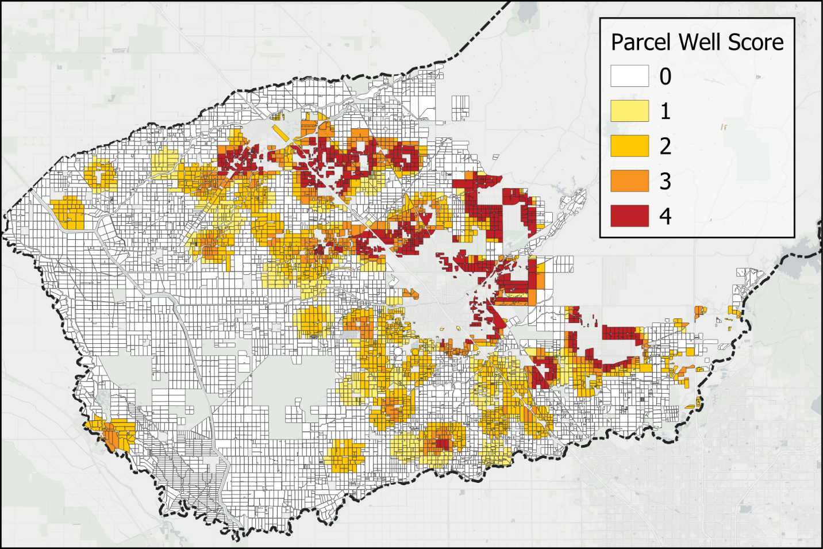

Key Goals and Outcomes: Support Disadvantaged Communities
Projects that generate benefits to disadvantaged communities will be prioritized. This includes projects that are proximate to disadvantaged communities. However, most of Madera County is classified as a DAC under the most recent publication (2022). Therefore, parcels are scored based on proximity to local communities/cities (i.e., existing development). Community data are developed from current county GIS layers. Figure 5 illustrates the communities included.

Figure 5. Madera County Community Locations and 2022 DAC Classification
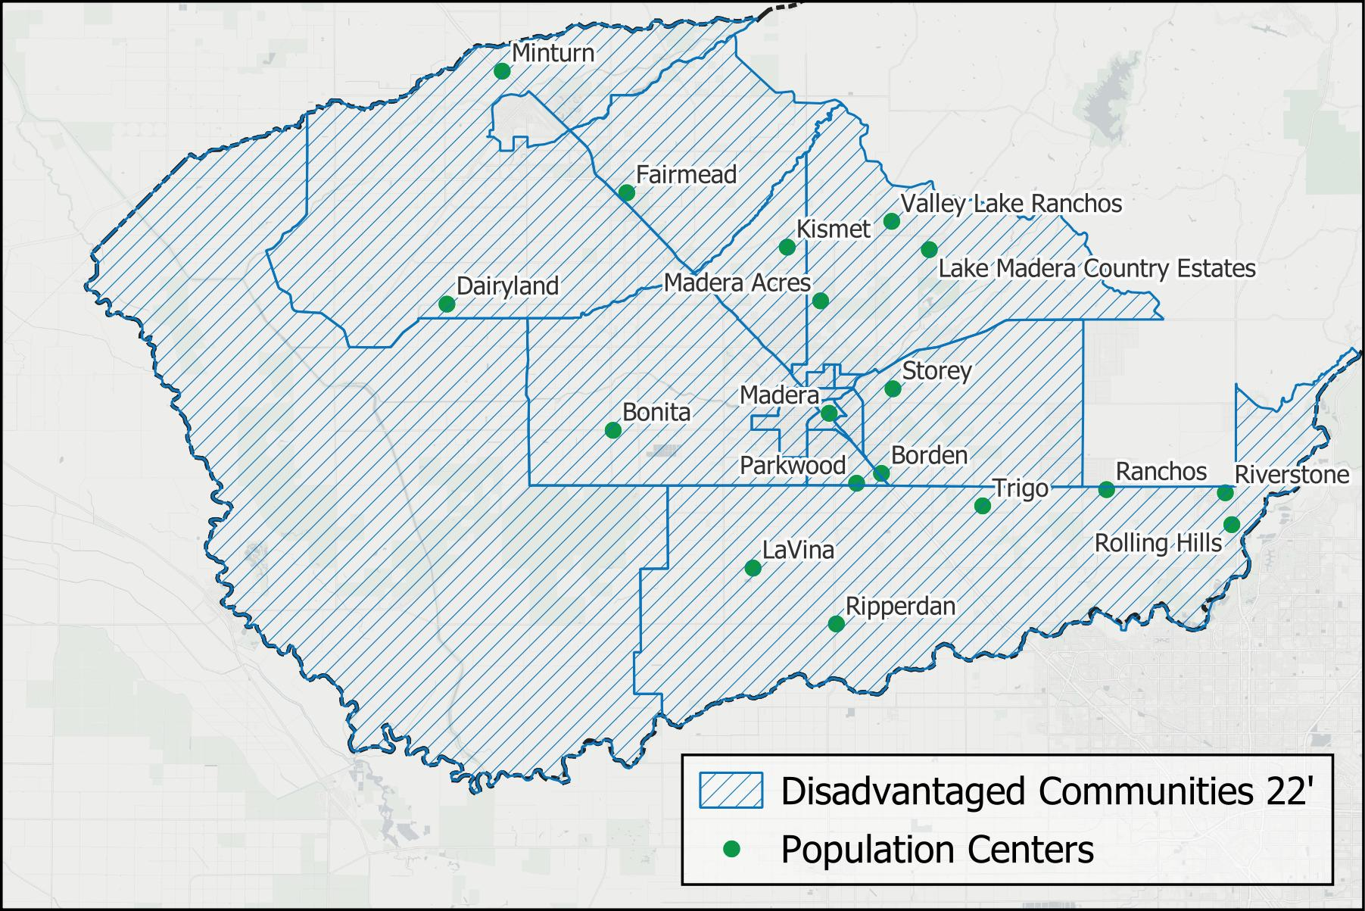
This scoring is spatial criteria. A project is assigned a score based on the proximity of the parcel to the community. Projects not next to a community receive 0 points. Projects directly adjacent to a community receive 4 points. Figure 6 illustrates the scoring.

Figure 6. Madera County MLRP Community Score
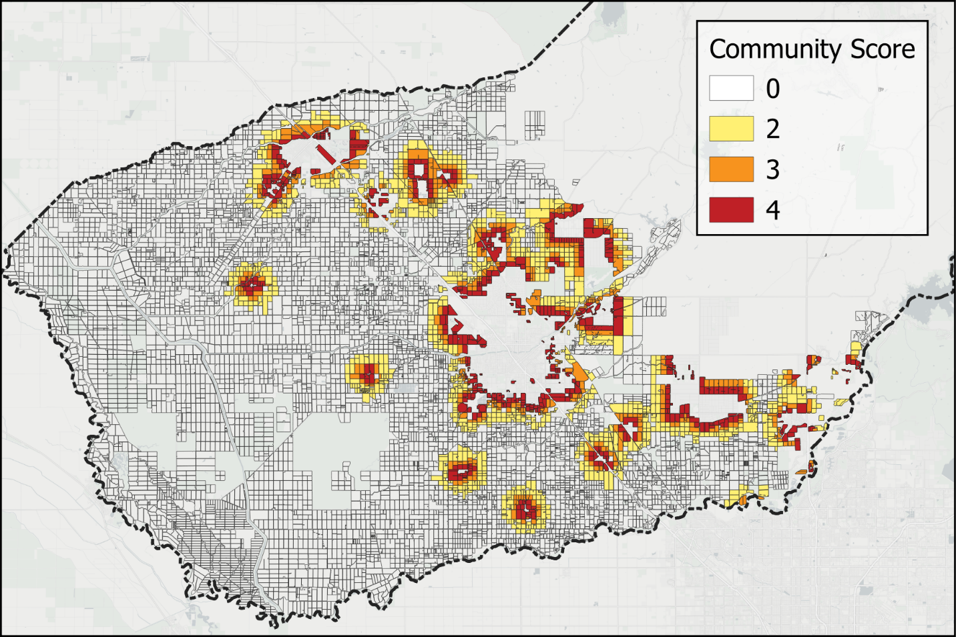

Key goals and outcomes: buffer waterway areas
Projects that are near existing water ways will be prioritized because these may provide additional flood control benefits or ecosystem connectivity opportunities. High and low priority streams were reviewed and analyzed. High priority streams are those in the State Flood Control Plan. Low priority streams are other waterways. Figure 7 illustrates the water ways. Also refer to the Madera County Flood Contingency Map for more information.

Figure 7. Madera County Waterways included in MLRP
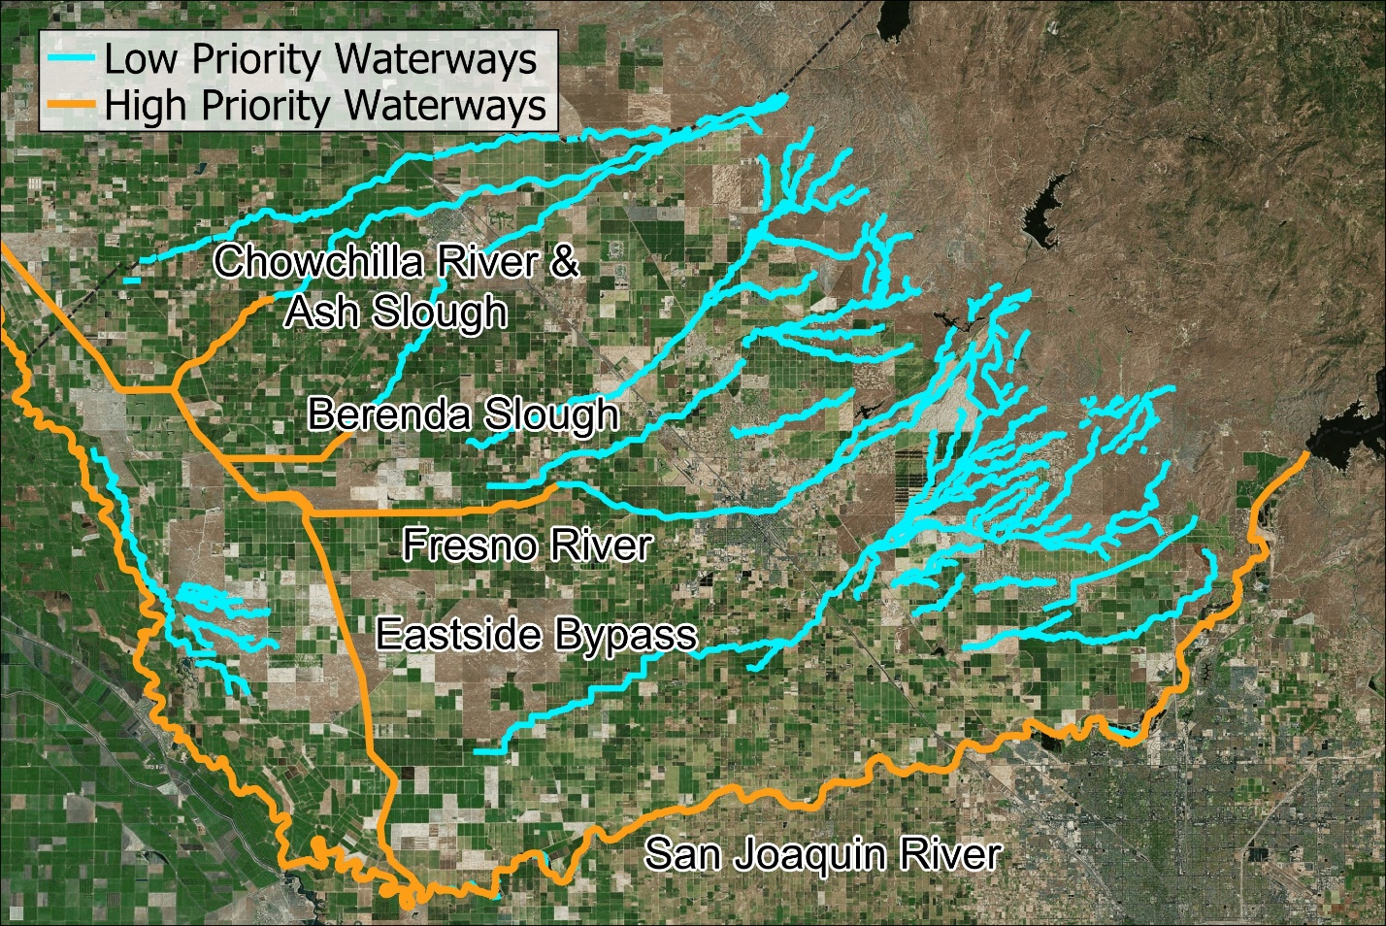

Parcels are scored based on proximity to low and high priority waterways. High priority waterways are identified for having high flood risk. However, scores are conditional on project type. For example, a project to switch crops near a water way would receive a score of 0 for this category because it would not provide any flood control or ecosystem benefit relative to the existing condition. Similarly, a project to add habitat on a parcel adjacent to a stream course, but only on a portion of the parcel furthest removed from the stream course may be viewed as not proximate and therefore not receive a score. Projects adjacent to a high priority waterway receive a score of 4 points. Projects adjacent to a low priority waterway receive a score of 2 points. Figure 8 illustrates the scoring.

Figure 8. Madera County MLRP Water Way Score
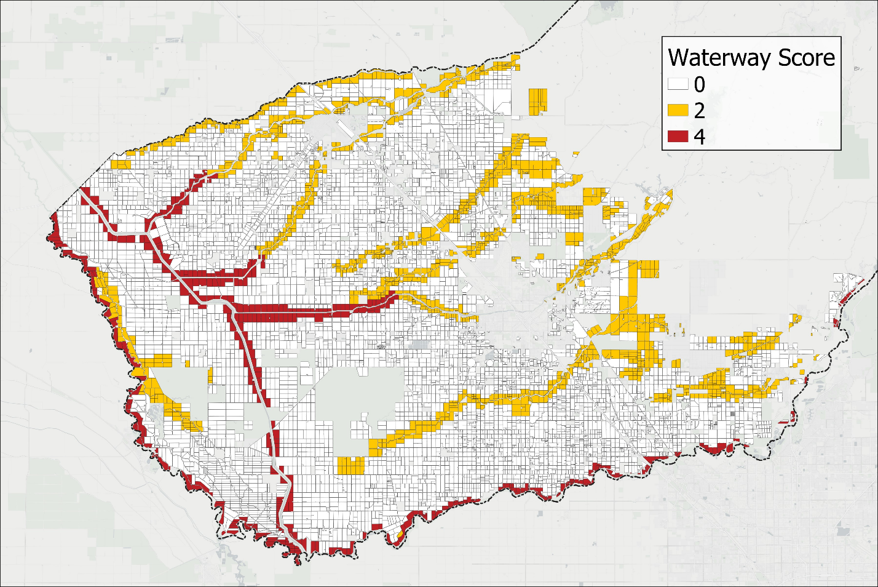

Proposal Quality and Feasibility: Proposal Completeness
The quality and thoroughness of the proposed project type will be scored. Review will assess level of detail in the proposal, steps for implementation, coordination with project partners, and preliminary work on environmental documentation and other permitting. Table 3 summarizes the proposal completeness points and scoring.
Table 3. Proposal Completeness Scoring
Work Plan Quality Elements | Max Points
Does the work plan adequately detail the steps necessary to implement the proposed project? | 2
Does the work plan include a listing of the permits required by the project and their status including CEQA? | 1
Does the work plan identify necessary project partners such as solar companies, water districts, or conservation entities? | 1
Max of 4 points

Proposal Quality and Feasibility: Budget
The MLRP is a taxpayer funded program. Projects will be reviewed and scored on the basis of the budget (cost) estimate submitted, the level of detail presented in the budget, and the reasonableness of the cost estimates. Reviewers will assess the level of detail related to specific project expenses, all expense categories (e.g., capital and operating costs), and prices and costs applied (e.g., were bids solicited and presented in the proposal).
The proposal budget may include the following three cost categories: (1) direct landowner costs for project development, design, installation, and operation, (2) any forgone income from removing the land from its current cropped use, appropriately adjusted for the income from the repurposed land use and the water supply available to the land, and (3) any additional costs for the provision of public co-benefits created by the project.
Applicants may secure additional funding sources to assist with project implementation costs. For example, the regional air board has offered payments for orchard recycling. Applicants are encouraged to secure such “stackable” funding streams. An Applicant may decide to take these additional payments into account and reduce the funding requested from MLRP. An additional score of up to 2 points is added to encourage projects that enroll MLRP land at the lowest cost per acre, which awards additional points to lands that propose relatively small, but otherwise beneficial projects and may be in areas that are already impacted by other GSP requirements. To encourage all of this, the budget is weighted proportionally more than other scoring components (totaling 8 points instead of 4 points).
Applicants are encouraged to develop reasonable bids and work with the TA Team to submit a reasonable project budget. Projects judged to have inflated budget proposals will be ranked lower and may not be funded at all. Madera County reserves the right to review a budget proposal and reject the entire project if it is judged to be unreasonable.
Table 4 summarizes the proposal budget points and scoring.
Table 4. Proposal Budget Scoring
Budget Quality Elements | Points
Does the budget provide detail on all expenses needed to complete the Workplan? | 1
Does the budget provide unit quantities for relevant expenses including but not limited to labor hours and bulk material quantities. | 1
Does the budget include separate estimates for upfront and ongoing costs? | 1
Do budget costs reflect market prices for goods and services? | 1
Does the project enroll MLRP acreage at a reasonable cost per acre (Under $10,000 per acre = 2 pts, $20,000 - $10,001 per acre = 1 point, over $20,000 per acre = 0 points) | 2
Is the overall budget reasonable, represent a strategic use of MLRP funds (i.e. considers other funding opportunities or includes other funding sources), and appropriate for the project type and level of benefits provided? | 2
Max of 8 points

Proposal Quality and Feasibility: Project Schedule
The scoring of the proposed schedule is based on the level of detail as well as the timeline for full project implementation. This will include reviewing proposed completion of key tasks including permitting, construction, and monitoring. The overall feasibility of the project will be reviewed. Table 5 summarizes the proposal schedule points and scoring.
Table 5. Proposal Schedule Scoring
Project Schedule Elements | Points
Does the project schedule clearly define expected completion dates of key project elements including but not limited to key construction deadlines, monitoring and assessment deadlines, and expected permitting and certification dates? | 2
Will the project be implemented in a timely manner that is consistent with the complexity of the project, and is within the DOC program period? | 2

Proposal Quality and Feasibility: Project Monitoring Plan
Both Madera County and DOC require a project monitoring plan that details how the project will be monitored, including calculation of benefits and all co-benefits created by the project. The proposed project monitoring plan should include sufficient detail in the provision of co-benefits, detail about the frequency of monitoring, and adequate funding (requested as part of the project budget) to implement the monitoring plan. Monitoring for continued generation of the project’s benefits will be a requirement of the County’s agreement and will be required for the duration of the project (minimum of 10 years). Table 6 summarizes the proposal monitoring plan points and scoring.
Table 6. Proposal Monitoring Plan Scoring
Project Schedule Elements | Points
Does the project have a plan for monitoring, assessment, and reporting of project outcomes? | 2
Does the monitoring plan include a reasonable timeline, feasible project monitoring steps, and a method for quantifying project co-benefits? | 2

Criteria Assessment
The pre-proposal application review, project proposal review, and scoring process for participation in the Madera County MLRP will be completed by a criteria assessment team of between three to five reviewers designated by the County. Reviewers who are part of the criteria assessment team are different and distinct from the parties who are part of the MLRP Madera TA Team. Each component of the scoring and assessment process is designed to ensure that successful proposals align with MLRP Madera’s goals and outcomes, while also ensuring an impartial and objective review. Projects will be assessed based on the factors defined in this Madera County MALRP.
Each project is scored using the rubric described in the section above. Points will be assigned to each category. Projects that receive the highest scores will be prioritized for funding, with the final decision for the project portfolio recommendation made based on the available budget and the overall strategic goals of the program (as described in Section VII). This transparent review process is designed to maximize the effectiveness of the program, ensuring that funded projects deliver meaningful and lasting benefits.
Once the scoring process is complete, the MLRP Madera administrative team will post information about the project portfolio recommendation to the MLRP Madera web page. This information will include descriptions of the projects selected, how they each scored, and an explanation for the portfolio recommendation. There will be a public comment period for feedback on the selected projects and the portfolio recommendation.

Incentive Payment Structure
The MLRP is a voluntary program. The Madera County MALRP must provide a fair total incentive payment that is sufficient to entice a willing landowner to participate in the program. In addition, MLRP is intended to encourage land repurposing that achieves direct and tangible co-benefits to surrounding communities and the environment.

Payment Categories
The MLRP Madera program will offer an incentive payment to successful projects that enter the program. The incentive payment will be based on the budget that is presented in the project proposal. The MLRP Madera program includes a $1 million cap for the total incentive payment per project. Prospective projects with budgets that exceed $1 million may be considered for MLRP Madera funding as an exception to this cap if the project clearly demonstrates that it provides a unique opportunity to deliver co-benefits that meet MLRP objectives. Consideration for an exception to the $1 million total project budget cap will be made on a case-by-case basis with Madera County reserving the right to make the final determination on any exceptions, including the amount of additional funding that would be granted.
The total incentive payment may include the summation of three budget categories, which are: (1) direct landowner costs for project development, design, installation, and operation, (2) any forgone income from removing the land from its current cropped use, appropriately adjusted for the income from the repurposed land use and the water supply available to the land, and (3) the public co-benefits created by the project.
Table 7 summarizes the components of the MLRP Madera incentive payment approach.
Table 7. MALRP Madera Incentive Structure Overview
Category | Description | Subcomponents
1. Direct Project Costs | Compensation for project development, implementation, operating, and maintenance costs | - Overhead/admin  - Planning  - Design  - Permitting  - Legal/professional review  - Project construction  - Project OM&R
2. Forgone Returns | Payment to cover returns that would have been realized under the existing land use, adjusted to reflect water use and/or any income from the repurposed land use | - Farming returns for the current crop(s), adjusted to reflect expected water availability  - Other project financial impacts (e.g., removing land from Williamson Act)
3. MLRP Benefits | Additional bonus payment(s) for public “multi” benefits created by the project | - Each MLRP co-benefit category is a potential subcomponent (e.g., alternative crops, solar, habitat, etc.)
TOTAL INCENTIVE PAYMENT = 1+2+3

Applicants are encouraged to review project structure and potential payments with their legal and tax advisor. Incentive payments would be income that would also include offsetting expense (e.g., direct project costs are a reimbursement). Questions regarding property tax assessments can be directed to the County Assessor’s Office.

Component 1: Direct Project Costs
Direct project costs will be reimbursed. Ongoing maintenance, operations, and replacement (OM&R) cost would continue for the duration of the 10-year project. The present value of these annual costs is included in the total direct project cost. Direct project cost components generally include but are not limited to:
- Project planning and design
- Any irrigation system work and reconfiguring the land for co-benefits
- Purchasing plants and establishing pollinator habitat, solar, recharge basins or other activities
- Habitat establishment including weed barrier, bed preparation, weed management, etc.
- Ongoing limited irrigation, maintenance, and replacement
- Direct project costs should be calculated using bids solicited by the landowner.

Component 2: Foregone Returns
A project may result in forgone income losses for the landowner and generate additional income streams. The MLRP will only pay for the net loss to the landowner. For example, if the landowner can fully irrigate the parcel in the absence of this project. The project provides a water savings benefit. Therefore, the landowner is giving up the opportunity to continue farming the land for the 10-year duration of the contract.
This payment must be adjusted for any private benefits provided by the MLRP project. For example, switching from almonds to a lower water-use crop, such as olives. This payment also will adjust for any reduction of water to the parcel that may accompany GSA specific programs, such as a groundwater allocation, where the parcel may have been unable to generate returns due to reduced water supply, regardless of the project. It is the applicant's responsibility to estimate and propose a payment for forgone returns as part of the project application package. A team of technical advisors will be available to assist. The project proposal is reviewed and scored based on the reasonableness of the requested payment for forgone returns. A proposal may be rejected if the requested incentive payment for forgone returns does not account for alternative land uses, changing groundwater allocation, or similar future adjustments in a reasonable manner.

Component 3: MLRP Benefits
A premium above direct costs and forgone farming income is a component of the Madera MLRP payments to encourage landowner participation and pay for public benefits created by the project.
A project payment of $2,000 per acre per co-benefit will be applied to each project. A maximum of $6,000 per acre (up to three co-benefits) will be applied. Co-benefit payments are only calculated and applied to project budgets that have not already reached the $1 million cap for MLRP Madera project funding from direct costs and foregone returns (budget categories 1 and 2). Total payment under Category 3 will be capped at 10% of the total project incentive payment or $100,000, whichever is less, and only when the project has not exceeded the $1 million cap. Adjustments to the calculation for a project’s total co-benefit payment, including the $2,000 per acre per co-benefit calculation and the $6,000 maximum may be considered on a case-by-case basis based on the unique considerations of each project.
Project co-benefits are defined in this MALRP and through multiple stakeholder meeting and public workshops for the project in late 2023 and early 2024. The co-benefits are established and will not be modified. Each project proposal will be reviewed by the technical team to determine whether co-benefits are appropriate, and any co-benefits funded by the MLRP will be included in the contract between the landowner and Madera County.

Total Incentive Payment
The total incentive payment is the sum of components 1, 2, and 3 as defined above.
Projects are partially evaluated (i.e., scored) based on the level of detail and cost-effectiveness of the proposed budget (see Section VII). Therefore, applicants are encouraged to develop reasonable bids and work with the MLRP Madera TA Team to submit a reasonable project budget. Projects judged to have inflated incentive payment proposals will be ranked lower and may not be funded at all.

Payment Schedule
Incentive payments for the project will be structured in accordance with key milestones to ensure alignment with project progress. Payment can only occur after required DOC project approval. Absent DOC project approval, the County has no payment obligation to the Participant. These will be defined in a contract/agreement between the landowner and Madera County. The general payment schedule is expected to be:
- Reimbursement for Direct Repurposing Costs. This will be paid within thirty (30) days of receipt of sufficient documentation to justify these costs by Madera County.
- Reimbursement for Forgone Farming Income. A lump-sum payment will be made for forgone farming income during the duration of the project. This will be paid upon satisfactory verification that the project is operating. These will be split into an initial payment, and up to two milestone payments upon verification.
- Reimbursement for Project Co-Benefits. A payment for co-benefits generated during the duration will be provided. These will be split into an initial payment, and up to two milestone payments upon verification.
Madera County will have the right to withhold payments, or seek reimbursement of any payments if the project is found to be out of compliance with the terms of the agreement. The process and standards for making this finding will be defined in the agreement between the Owner/Applicant and the County.

Project Management and Monitoring Plan
Project monitoring is required by DOC. Madera County will monitor and verify that the Participant is complying with MLRP Madera program rules and contract terms, assess project performance, and quantify project benefits. Madera County may use a combination of water tracking technology, reports, staff time and site visits, and other resources to monitor and verify compliance of MLRP Agreement performance. Verification is performed by Madera County and/or its contractors to check that the land is being managed as outlined in the MLRP Agreement terms, which include managing for all project specified co-benefits.
The Participant shall make reasonable accommodations to allow access for compliance monitoring.

Termination
An executed MLRP Agreement is a binding commitment on the part of both the Madera County and the Participant and can be terminated at the discretion of the Madera County if it determines that a violation of one or more terms of the MLRP Agreement has occurred or is threatened to occur. If Madera County identifies a violation or potential violation, the Participant will have seven (7) days after receipt of notice to the Participant by Madera County of such violation to remedy the violation. This will be specified in the contract between Madera County and the Owner/Applicant.

Monitoring Plan
Madera County will monitor the project to ensure that the Participant is complying with the terms of the MLRP Agreement, assess project performance, and quantify project benefits. Monitoring is broken down into five core program components.

Component 1: Initial Data Collection and Project Information
The County will conduct an initial verification of Applicant contracted acres, the location of those acres, water supply sources supplying the contracted MLRP acres, water allocation (if applicable), and water use.
The County will develop data required to evaluate project benefits and performance. This may include information about the parcel, water use, location, proximity to domestic wells, and similar measures.
It is anticipated that information will be recorded in a standard geospatial database.

Component 2: Project Compliance
The County will conduct site visits at least twice per year to visually inspect project fields. In the first year of monitoring the County will verify that crops have been removed, if part of the project, and project development is proceeding in accordance with the proposed project timeline. In subsequent years the County will ensure that the repurposed land has not been returned to its original use and the grant-funded replacement use is functioning or functional pursuant to the approved project description. The County will provide advance notice to landowners of the site visits. Its staff will visually inspect the field and may take pictures or other documentation of the lands. Any deficiencies will be documented, and the landowner will be notified according to the terms of the Contract.
Project monitoring will continue until the contract expires, which will be a minimum of 10 years.
The County will work with the landowner to record the contract on the property title as appropriate. This will ensure that any future landowner is aware of the MLRP project terms and conditions.

Component 3: Quantify Project Benefits
A GIS database of MLRP parcels will be developed. This will show the location of the MLRP projects. In the future this may include information about project scoring criteria (when those are developed). Basic information will include parcel location, GSA, water district, acreage, and APN. The database will also include all spatial data used to evaluate parcel scoring and incentive payments.

Component 4: GSP Implementation and Integration
It is anticipated that monitoring will include annual and 5-year reporting for GSP updates and annual reports. This will be developed in coordination with the landowner GSA.
This component of monitoring may include preparing sections of the project summary for the GSP, or providing other data to support GSP updating efforts.

Component 5: Project Summary Reports
This component includes any contractual obligations for reporting about the project to DOC. The County will develop materials required to submit to DOC to document progress on the project and project outcomes.
This component may also include continued outreach to stakeholders (e.g., meetings, workshops, social media, other posts). A goal of the Madera County MALRP is to create projects that are scalable and can be replicated by others. Therefore, part of project implementation monitoring may include continued outreach and promotion by the County to highlight aspects of the project.
The monitoring plan will define project performance measures. Each MLRP Madera project must define performance measures based on the direct benefits (e.g., net water savings) and any co-benefits provided by the project.
The performance measures will document the project co-benefits, qualitatively or quantitatively, in the required DOC reporting materials and other reports as defined above in the Monitoring Plan outline.

Quantifying Program Benefits
Project benefits (e.g., net water savings) and all co-benefits must be quantified using best practices. A baseline will be calculated and used to measure the incremental benefits attributable to the project. For example, project benefits change as the GSA water allocation changes over time. Each year project groundwater savings benefits will be estimated for the current year and all future years based on the adopted GSA allocation schedule at that time. A quantitative analysis will be performed and project benefits that cannot be quantified will be qualitatively describes. This will include quantifying project benefits for:
- Water
- Air Quality
- Employment
- Flood Risk
- Habitat
- Recreation or cultural space
- Renewable Energy
- Tribal/Cultural Use Benefit
- Soil Quality
- Water Quality
The MLRP Madera team will quantify all project benefits periodically and may include updates in GSP reporting (e.g., annual reports and 5-year updates). A concise narrative of project benefits, including all co-benefits, will be developed and may be integrated into appropriate sections of the GSP Annual Reports and 5-year GSP Updates.

DOC Grant Period Implications
The project management and monitoring plan outlined above is supported by the Regional Block Grant funding awarded to Madera County through the DOC grant. This grant contract will expire in June 2027, after which the County will need to consider funding needs for Monitoring Plan activities for the full 10-year project implementation period. To continue implementation of Monitoring Plan activities through the end of the MLRP 10-year project implementation period, a County-supported funding mechanism will need to be addressed.

Consistency and Data
This section documents the consistency of the Madera County MALRP with existing GSPs and examines the data supporting its implementation. By aligning with key objectives of the GSPs, the MALRP demonstrates a commitment to reducing water demand and enhancing groundwater recharge and other co-benefits, where feasible, through strategic land use changes. The MALRP is underpinned by robust data, including GIS data, land use data, crop market data, and agricultural water use statistics, ensuring that decisions are data-driven and focused on achieving long-term sustainability goals. This evidence-based approach not only supports the plan's feasibility but also underscores its role in promoting regional resilience against water scarcity challenges.

Consistency with Regional GSPs
The MALRP aligns closely with the regional GSPs by promoting land use practices that support long-term groundwater sustainability. The MALRP prioritizes the conversion of water-intensive agricultural areas to less water-dependent uses, reducing overall groundwater extraction in critical areas. By integrating land repurposing with recharge projects and other potential co-benefits, the MALRP enhances groundwater recharge and mitigates overdraft risks. Furthermore, it supports the GSP's objectives that contribute to the region's ecological health, ensuring that land use changes complement the overarching goals of groundwater preservation and resilience.

Consistency with Best Available State, Regional, and Local Data
The MALRP is grounded in the best available state, regional, and local data, ensuring that its guidelines and intended outcomes are both effective and obtainable. The MALRP leverages local GSP data including but not limited to water balances, land use, cropping, and hydrologic information. Local and state well data are used to define communities vulnerable to groundwater depletion and at-risk wells. Regional and state data on agricultural practices, markets, costs, and returns, as well as water use, informs targeted land use changes and incentive payment structure. Local data, including soil composition, habitat, and land productivity among others, available in geospatial form, further refines the MALRP, ensuring that repurposing efforts are tailored to the specific needs defined by stakeholders.
By integrating this comprehensive data set, the Madera County MALRP aligns with scientific best practices and supports informed decision-making, ensuring consistency with broader sustainability efforts in Madera County. It is anticipated that this MALRP will continue to be refined and expanded in the future and may be tailored to other grant programs or funding opportunities, further leveraging this database.

Attachments
This section provides additional documents and materials that support various sections of the Madera County MALRP. Contents include:

MLRP Project Implementation Review Packet (Template)
Provides the checklist/form that DOC uses to facilitate the review and approval of all MLRP projects submitted for funding approval.

Pre-Application Form
Provides the form all Applicants must submit prior to developing and submitting a project proposal for participating in the MLRP Madera program.

Section VII: Project Solicitation and Selection Process Summary Table
Provides an overview of the MLRP Madera project solicitation and selection process, including the phases, activities, expected timelines and milestones.

MLRP Project Implementation Review Packet (Template)

Project Implementation Approval Packet
This packet is intended to facilitate the review and approval of projects for implementation using Multibenefit Land Repurposing Program funding.
Instructions for grantee: Please complete all sections of this packet except for those marked “DOC Grant Manager Review”/greyed out. Once you’ve completed all sections, submit this packet in word format, along with any supplemental documents required, to your grant manager for review.
When a completed packet is submitted, the grant manager will review the packet and either: approve the project for funding as is, reject the project as is, or return the packet to the grantee with a request for revisions and/or additional information. Once the packet is determined to be complete and a decision has been reached, the DOC grant manager will convert the document to a PDF and return it to the grantee with a final determination. If the project is approved, the grantee may proceed with the project using MLRP funds. If the project is rejected, the grant manager will note the reason(s) why.

Review Summary
Basic Information
Project Name
Grantee
Sub-grantee (if applicable)
Project County
Senate and Assembly Districts | Senate: | Assembly:
MLRP funding amount | $
Total project amount | $
SALC Grant Manager

DOC Grant Manager Review
Packet complete: | Yes ☐ No ☐
Project approved for implementation: | Yes ☐ No ☐ Revisions Required ☐

Program Priorities
Project provides meaningful benefits to a disadvantaged community: | Yes ☐ No ☐
Project will be conducted on lands least viable for agriculture: | Yes ☐ No ☐
Project contributes to resource connectivity: | Yes ☐ No ☐

Packet Completeness Checklist

Instructions for grantee: Complete the below checklist for each project. Grantees should provide all of the following for review unless a particular item is not relevant to the project. If an item is not relevant, the grantee must provide a justification to the grant manager describing why the item is not relevant. The grant manager may waive the requirement that a particular item should be submitted with management concurrence.

All Packets should include the following:
DOC GM | Grantee | Item
☐ | ☐ | Project summary
☐ | ☐ | Project designs
☐ | ☐ | Project maps
☐ | ☐ | Implementation timeline
☐ | ☐ | Budget
☐ | ☐ | Proof of site access
☐ | ☐ | Best Practices for Disadvantaged Community Engagement Checklist
☐ | ☐ | Baseline documentation (at a minimum, before photos)
☐ | ☐ | Draft monitoring plan (at a minimum, should include a list of performance measures to track outcomes)
☐ | ☐ | Draft management plan (if available)
☐ | ☐ | CEQA/NEPA documentation
☐ | ☐ | GSA certification that groundwater recharge achieved will be subtracted from the groundwater available for extraction by water users (if applicable)
☐ | ☐ | Permits (if available)

DOC Grant Manager Review

For any unchecked items, initial below to certify that submission of the items has been waived:

______ ______
Grant manager Program Manager

Reviewer Comments: Click or tap here to enter text.

Basic Project Information

Instructions for Grantee: When completing this section, please refer to Guidelines pages 7-9 for additional details regarding project types and requirements.
Briefly describe the project: Click or tap here to enter text.

Project Type
Check all that apply:
☐ | Rewilding landscapes
☐ | Creation of multi-benefit recharge areas
☐ | Restoring floodplains
☐ | Transitioning irrigated land to dryland farming or non-irrigated rangeland
☐ | Transitioning to less water intensive crops, including for native seed production
☐ | Planting cover crops or conservation cover
☐ | Reestablishment of tribal land uses
☐ | Implementation of tribal cultural practices
☐ | Facilitation of renewable energy projects that have an overall net GHG reduction
☐ | Creation of parks or community recreation areas
☐ | Incentive payments to landowners, farmers, and ranchers
☐ | Land acquisitions to facilitate land repurposing and protect repurposed land uses
☐ | Voluntary land transfers to tribes or qualified public entities to facilitate land repurposing and protect repurposed land uses
☐ | Easement acquisitions, including conservation easement and flood easement acquisitions, to facilitate land repurposing and protect repurposed land uses
☐ | Other: [describe]

DOC Grant Manager Review
If incentive payments to landowners, farmers, and ranchers is checked, are those payments linked to at least one other, non-acquisition project type?
☐ Yes ☐ No ☐ N/A

Only answer questions (a) and (b) if you checked “yes” above:
(a) Are those payments based on the conservation outcomes achieved and the duration of the benefit provided?
☐ Yes ☐ No ☐ N/A

(b) Did the grantee work with DOC on the development of those incentive payments?
☐ Yes ☐ No ☐ N/A

If an acquisition or land transfer box is checked, is the project linked to at least one non-acquisition project type?
☐ Yes ☐ No ☐ N/A

Reviewer Comments: Click or tap here to enter text.

Program Goals

Instructions for Grantee: Complete this section to determine if your project is eligible for MLRP implementation funding. Projects do not need to support all of the program’s goals to be eligible for implementation, but rather they must be generally consistent with the program’s goals to be eligible. If you are unsure whether a project meets this requirement, you may check “unsure,” complete the rest of the packet, and submit the to your DOC grant manager for review and discussion.

Is the project consistent with the program’s goals?
☐ Yes ☐ No ☐ Unsure
Briefly describe how: Click or tap here to enter text.

Check the goals that the project best supports:
☐ | Supports coordinated, regional and basin-scale efforts to achieve groundwater sustainability in critically overdrafted basins and in high and medium priority basins where a state emergency drought declaration has been declared
☐ | Supports long-term repurposing of lands least viable for agriculture and multi-benefit opportunities that convert land to less intensive water uses while maintaining natural and working lands
☐ | Provides short- and medium-term drought relief
☐ | Supports regional efforts to sustain land-based economies that are impacted by groundwater sustainability measures
☐ | Reduces groundwater use
☐ | Creates or restores wildlife habitat and wildlife connectivity, including seasonal wetland habitat to replenish aquifers
☐ | Improves groundwater supply, including through groundwater recharge, improved baseflows in rivers and streams, and groundwater supply improvement for fish and wildlife habitat
☐ | Supports nature-based solutions to reduce the impacts of hazards on lives, property, and the economy from overdrafted groundwater basins
☐ | Provides benefits to disadvantaged communities and socially disadvantaged farmers and ranchers
☐ | Fosters partnerships and collaboration among diverse entities to enable regional scale leadership to meet this program’s goals
☐ | Develops scalable, transferable land repurposing models
☐ | Supports farmer, rancher, and farm worker leadership in multi-benefit land repurposing strategies and project implementation

DOC Grant Manager Review
Is the project consistent with the program goals? ☐ Yes ☐ No

Reviewer Comments: Click or tap here to enter text.

Project Benefits and Outcomes

Instructions for Grantee: Complete the following sections to determine if your project is eligible for MLRP implementation funding. You must check “yes” to all of the questions in the Project Benefits and Outcomes sections, unless otherwise specified, for the project to be eligible for implementation funding. If you are unsure whether a project meets a certain requirement, you may check “unsure,” complete the rest of the packet, and submit the to your DOC grant manager for review and discussion.

Project Benefits
Benefits | Yes | No | Unsure | Describe | DOC GM Initials
Is the project consistent with the relevant GSP? | ☐ | ☐ | ☐ |  | ____
Will the project result in groundwater sustainability benefits? | ☐ | ☐ | ☐ |  | ____
Will the project result in at least one other community health, economic wellbeing, habitat, flood, renewable energy, or climate benefit? | ☐ | ☐ | ☐ |  | _____

Duration of Benefits
Instructions for Grantee: Projects must result in multiple benefits lasting at least 10 years, unless they are directly responding to a state emergency drought declaration, in which case, benefits must be reasonably durable.

Answer the following questions to determine if the duration of the benefits provided meets the requirements of the program. You must answer “yes” to question 1, or “yes” to both questions 2 and 3 for the project to be funded with MLRP dollars.

- Will the multiple benefits last for at least ten years? ☐ Yes ☐ No ☐ Unsure

Briefly describe how long the benefits will be provided for, and how they will be maintained for at least 10 years: Click or tap here to enter text.

(Only answer questions 2 and 3 if you answered “no” to question 1.)

- Does the project directly respond to a state emergency drought declaration?
☐ Yes ☐ No ☐ Unsure

Briefly describe how: Click or tap here to enter text.

- Are the benefits provided reasonably durable? ☐ Yes ☐ No ☐ Unsure

Briefly describe how: Click or tap here to enter text.

DOC Grant Manager Review
Does the project meet the Program requirements regarding project benefits and the duration of those benefits? ☐ Yes ☐ No

Reviewer Comments: Click or tap here to enter text.

Project Outcomes

Does the proposal maximize project outcomes? ☐ Yes ☐ No
Briefly describe how: Click or tap here to enter text.

Check all that apply:
 | Outcome | Performance Measure(s)
☐ | Reduced groundwater use
☐ | Increased groundwater recharge
☐ | Improved baseflows in rivers and streams
☐ | Transition of land to less water intensive, regenerative uses while maintaining natural and working lands
☐ | Creation and/or restoration of wildlife and pollinator habitat and/or migratory resources
☐ | Protection of cultural resources
☐ | Improved water quality
☐ | Land use agreements to accomplish prioritized opportunities
☐ | Quantified achievement of multiple benefits of the program
☐ | Incorporated participation from multiple partners, collaborators, and funding sources
☐ | Replicability and scalability
☐ | Integrated benefits to disadvantaged communities and tribes
☐ | Increased community outreach, involvement, and education
☐ | Increased regional workforce development opportunities and support of local business
☐ | Diversified economic opportunities

Does the grantee have a draft monitoring plan developed for the project? ☐ Yes ☐ No

Does the grantee have a draft management plan developed for the project? ☐ Yes ☐ No

DOC Grant Manager Review
Does the proposal maximize project outcomes? ☐ Yes ☐ No

Are the performance measures sufficient to track project outcomes for the duration of the benefits provided? ☐ Yes ☐ No

Reviewer Comments: Click or tap here to enter text.

Groundwater Recharge Assessment

Will groundwater recharge be achieved through the implementation of this project?
☐ Yes ☐ No

Instructions for Grantee: Complete the following only if the project meets the program goals, project benefits, project duration, and project outcomes requirements, and the “yes” box is checked above. The GSA with jurisdiction over the project area must subtract the groundwater recharge achieved by the project from the groundwater available for extraction by water users for the duration of the benefits paid for by the program.

What is the estimated recharge that will be achieved for the duration of the benefits provided? Click or tap here to enter text.

Has the GSA with jurisdiction over the project area certified that the groundwater recharge to be achieved by the proposed project will be subtracted from the groundwater available for extraction by water users for the duration of the benefits paid for by the program?
☐ Yes ☐ No

Is the GSA certification attached for inclusion in the project file? ☐ Yes ☐ No

DOC Grant Manager Review
Has the GSA certified that the groundwater recharge to be achieved by the proposed project will be subtracted from the groundwater available for extraction by water users for the duration of the benefits paid for by the program?
☐ Yes ☐ No

Is the GSA certification acceptable to DOC? ☐ Yes ☐ No

Link to certification:

Reviewer Comments: Click or tap here to enter text.

Program Priorities

Instructions for Grantees: Grantees must prioritize projects that:
- Meaningfully benefit disadvantaged communities
- Are conducted on lands that are least viable for irrigated agriculture
- Contribute to resource connectivity (e.g., connectivity of habitat, agricultural landscapes, renewable energy centers, etc.)

Complete the following sections to identify which priorities the project meets, if any.

Disadvantaged Community Benefits
Instructions for Grantees: Identify and describe each disadvantaged community near the proposed project and the benefit(s) the project will provide to that community. If more than one disadvantaged community is located near the proposed project, duplicate this section, including the Community Engagement and Benefit(s) Provided questions, and complete it for each relevant disadvantaged community. Supporting documentation demonstrating engagement of nearby disadvantaged communities is required. Supporting documentation may include meeting sign-in sheets, letters of support for the final project design from disadvantaged community members or representatives, etc.
Community Name | Census Tract(s) | Description

Community Engagement
Did you or a subgrantee engage the above disadvantaged community in the project’s development? ☐ Yes ☐ No

Did you or a subgrantee utilize best practices for Disadvantaged Community Engagement?
☐ Yes ☐ No

Is the Best Practices checklist attached? ☐ Yes ☐ No
If the Best Practices checklist is not attached, describe how the disadvantaged community has been engaged in the project’s development: Click or tap here to enter text.

Does the supporting documentation show disadvantaged community support for the project? ☐ Yes ☐ No
Is supporting documentation attached?
☐ Yes ☐ No

Benefit(s) Provided
Does the project provide a meaningful benefit to the disadvantaged community described above? ☐ Yes ☐ No

If yes, describe the benefit(s) provided: Click or tap here to enter text.

If no, describe why: Click or tap here to enter text.

Agricultural Viability
Will the project be conducted on lands that are least viable for irrigated agriculture?
☐ Yes ☐ No

Briefly describe the methodology used to make this determination: Click or tap here to enter text.

Resource Connectivity
Will the project contribute to resource connectivity (e.g., connectivity of habitat, agricultural landscapes, renewable energy centers, etc.)? ☐ Yes ☐ No

If yes, describe:? Click or tap here to enter text.

Project Justification
Instructions: If the project is not conducted on lands least viable for agriculture, does not contribute to resource connectivity, and does not meaningfully benefit disadvantaged communities, answer the following questions.

Are there other land repurposing projects that meet the program priorities that have not yet been funded? ☐ Yes ☐ No

If yes
Why is this project being brought forward before projects that better meet the program priorities? Click or tap here to enter text.

If this project is funded, would that impact the funding available for those projects that better meet the program priorities? Click or tap here to enter text.

If no
Why has the grantee not identified projects that meet the program’s priorities?
Click or tap here to enter text.

Why should this project be funded in lieu of projects that better meet the program’s priorities?
Click or tap here to enter text.

DOC Grant Manager Review

Disadvantaged Community Engagement
Did the grantee identify each disadvantaged community near the proposed project?
☐ Yes ☐ No
The grantee’s description of each disadvantaged community was:
☐ Poor ☐ Fair ☐ Good ☐ Excellent
The grantee/subgrantee’s engagement of relevant disadvantaged communities was: ☐ Poor ☐ Fair ☐ Good ☐ Excellent

Project Prioritization
Does the project provide a meaningful benefit to the disadvantaged communities described?
☐ Yes ☐ No

If no, is the grantee’s justification for the lack of benefits sufficient to allow the project to move forward? ☐ Yes ☐ No
Will the project be conducted on lands least viable for agriculture? ☐ Yes ☐ No
Will the project contribute to resource connectivity? ☐ Yes ☐ No

If you answered no to the above questions, is the grantee’s justification for this project sufficient to allow use of MLRP funds for this project at this time? ☐ Yes ☐ No
Reviewer comments: Click or tap here to enter text.

Project Permitting and Site Access

Instructions for Grantee: Complete the following sections to help your grant manager determine whether the project is ready for MLRP implementation funding, or whether additional project development work might be needed before the project proceeds to implementation.

CEQA
Lead Agency: Click or tap here to enter text.

Is CEQA required for the project? ☐ Yes ☐ No

If yes
Document type: ☐ NOE ☐ Neg Dec/Mitigated Neg Dec ☐ EIR
Is CEQA complete? ☐ Yes ☐ No
State Clearinghouse Number: Click or tap here to enter text.
Link to relevant documents: Click or tap here to enter text.

If no
Is the project exempt from CEQA? ☐ Yes ☐ No
Is the project outside the definition of Project Choose an item.
Explain why: Click or tap here to enter text.
Statutory exemption: Choose an item.
Categorical exemption: Choose an item.
If categorical, is there an unusual circumstance: Choose an item.
If multiple: Click or tap here to enter text.

Permits
Are any permits required for the project? ☐ Yes ☐ No
List permits: Click or tap here to enter text.
Have all permits been acquired or does the grantee have a plan to acquire required permits before implementation begins? ☐ Yes ☐ No
Describe plan (if needed): Click or tap here to enter text.

Site Access
Does the grantee or subcontractor have verified access to the site for the duration of the project and for maintenance and monitoring purposes for at least 10 years following project implementation? ☐ Yes ☐ No

DOC Grant Manager Review
Further action required by grantee to comply with CEQA? ☐ Yes ☒ No
Further action required by grantee to obtain permits required? ☐ Yes ☐ No
Further action required by grantee to verify site access? ☐ Yes ☐ No
Reviewer comments: Click or tap here to enter text.

Pre-Application Form

PRE-APPLICATION FORM

- Applicant/Owner or Applicant/Owner Designee Information:

Applicant (Decision Maker): | Application Date:
Mailing Address: | Proposed Project Location:
Phone: | Email:
Proposed Project Description:
Contact mlrp@maderacounty.com with questions or to request assistance to fill-out this form..

- Parcel/Land Information: The following questions apply to the land being offered for enrollment through this application.

APN(s):
Number of Acres:
Water supply source including (if applicable) the location of well or wells used to irrigate the fields

- Are the land(s) being offered for the program within a Groundwater Sustainability Agency (GSA) and Madera County?
: ❑ Yes ❑ No

If yes, which GSA(s):
- Land Type (check all that apply):
❑ Private Land
❑ Public Land: ❑ Federal Government ❑ State Government ❑ Local Government
❑ Indian Land: ❑ Allotted ❑ Tribal Trust Land ❑ Tribal Non-Trust Land ❑ Other
- Control of Land Documentation (check all that apply):
❑ Deed or other evidence of land ownership
❑ Written lease agreement
❑ Other agreement or legal conveyance (describe):
- Is the land currently enrolled in any other relevant program(s)?
❑ Yes ❑ No
- Which program(s):
- Current Condition (check all that apply):
❑ Irrigated Agriculture
❑ Previously irrigated agriculture (date last irrigated):
❑ Other (describe):
- Proposed Project Information. The following questions apply to the project that would be proposed and implemented through the program. Applicants must propose a project that would implement at least one eligible project type to convert irrigated agricultural lands to a less water intensive use. Projects must provide at least one or more co-benefits, which are benefits in addition to any water savings provided by the project.
- Eligible Project Type (check all that apply):
❑ Community recreational area or cultural space ❑ Dryland Farming
❑ Floodplain Habitat ❑ Less Water Intensive Crop ❑ Rangeland (Managed Grazing Land)
❑ Pollinator Habitat ❑ Recharge Basin or Facilities ❑ Rotational Strip Cropping
❑ Renewable Energy (Solar) ❑ Wildlife Habitat
- Multibenefits (Co-Benefits) Created (check all that apply):
❑ Air Quality Improvement ❑ Employment Opportunities. ❑ Tribal or Cultural Benefit
❑ Soil Quality Enhancement ❑ Water Quality Enhancement ❑ Renewable Energy
❑ Habitat Creation ❑ Recreation or Community Space ❑ Flood Risk Mitigation

- Applicant Information: Select the business structure and enter the legal name, and tax identification number for all applicants who will be participants on the contract or agreement including the decision maker.

Business Structure (Mark with an X) |  | Applicant Legal Name | Tax Number  (last four digits)
Individual | Entity | Applicant Legal Name | Tax Number  (last four digits)
❑ | ❑
❑ | ❑
❑ | ❑
❑ | ❑
❑ | ❑
❑ | ❑

- If applicant is a legal entity or joint operation, do you have appropriate documents including proof to sign for the entity or joint operation?
❑ Yes ❑ No ❑ N/A

The applicant agrees not to start any financially assisted conservation practice or activity or engage the reimbursable services of a certified technical service provider before an obligating document is executed by Madera County.
The applicant may obtain a copy of the applicable program contract appendix, which defines the full terms and conditions of program participation from Madera County by emailing mlrp@maderacounty.com.

Applicant Signature

Section VII: Project Solicitation and Selection Process Summary Table

Note: The Solicitation and Selection Process timeline assumes review and approval of the Madera Multibenefit Agricultural Land Repurposing Plan (MALRP) by the Madera County Board of Supervisors at the Board Meeting on October 1, 2024.
 | Phase | Activity | Timing
1 | Pre-Solicitation | Draft MALRP Outreach and Input  MALRP Board of Supervisors Presentation | 8/28 – 9/18  10/1
2 | Pre-Application and Eligibility Screening | Solicitation Released, Pre-Application Window  Pre-Approval Notices | 10/4 – 11/22  11/29
3 | Project Proposal Development and Technical Assistance | MLRP Resource Fairs/Workshops for Applicants  1:1 Technical Assistance Sessions, Resource Navigation, and Stakeholder Outreach and Engagement Support for Developing Draft Proposals  Project Proposals Due  (Note: Applicants must be pre-approved through the pre-application and eligibility screening process in Phase 2 in order to submit a project proposal.) | 11/4 – 11/15  11/18 – 2/28  2/28
4 | Project Scoring and Selection | Project Scoring and Selection for Portfolio Recommendation  Public Comment Period on Portfolio Recommendation  DOC Project Proposal Review and Feedback  DOC Project Portfolio Approval | 2/28 – 3/14  3/17 – 3/28  3/17 – 4/25  4/25 – 5/30
5 | Contracting and Implementation | Award Notices and Contracting  Project Implementation and Incentive Payments | 4/25 – 6/30  May 2025 – June 2027
69

Hanak, Ellen & Escriva-Bou, Alvar & Gray, Brian & Green, Sarge & Harter, Thomas & Jezdimirovic, Jelena & Lund, Jay & Azuara, Josué & Moyle, Peter & Seavy, Nathaniel. (2019). Water and the Future of the San Joaquin Valley. 10.13140/RG.2.2.24360.83208.
Madera County Groundwater Sustainability Plans covering GSAs in the Madera, Chowchilla, and Delta Mendota Subbasins in Madera County.
The GSA groundwater allocation adopted after GSP development considers additional land use change in the county. The total level of demand management at full GSP implementation is approximately 113,000 acre-feet per year in Madera and 63,400 and 2,000 in Chowchilla and Delta Mendota.
Using the Department of Water Resources (DWR) DAC Mapping Tool.
California Department of Conservation, BestPractices_DACengagement_TEMPLATE, Google Docs, https://docs.google.com/document/d/143VoDJnKoHgwj9DJIvzXGBOn7RynfjzR/edit.
CASWRCB SAFER database: https://www.waterboards.ca.gov/drinking_water/certlic/drinkingwater/2022.html
CADWR Reported Dry Wells database: https://dwr.maps.arcgis.com/apps/dashboards/bd00ee8c357c449ca4ac5714bb95a81c
Madera County Water. Madera Flood Contingency Map. March 2023. https://www.maderacountywater.com/wp-content/uploads/2023/03/Madera-Flood-Contingency-Map.pdf.

